**VISVESVARAYA TECHNOLOGICAL UNIVERSITY**

**“JnanaSangama”, Belgaum -590014, Karnataka.**



**LAB REPORT**

**on**

**BIG DATA ANALYTICS**

**(20CS6PEBDA)**

***Submitted by***

**Kizhakel Sharat Prasad(1BM19CS074)**

***in partial fulfillment for the award of the degree of***

**BACHELOR OF ENGINEERING**

***in***

**COMPUTER SCIENCE AND ENGINEERING**



**B.M.S. COLLEGE OF ENGINEERING**

**(Autonomous Institution under VTU)**

**BENGALURU-560019**

**May-2022 to July-2022**

**B. M. S. College of Engineering,**

**Bull Temple Road, Bangalore 560019**

(Affiliated To Visvesvaraya Technological University, Belgaum)

**Department of Computer Science and Engineering**



**CERTIFICATE**

This is to certify that the Lab work entitled “**BIG DATA ANALYTICS**” carried out by **Kizhakel Sharat Prasad(1BM19CS074),** who is bonafide student of **B. M. S. College of Engineering.** It is in partial fulfillment for the award of **Bachelor of Engineering in Computer Science and Engineering** of the Visvesvaraya Technological University, Belgaum during the year 2022. The Lab report has been approved as it satisfies the academic requirements in respect of a **BIG DATA ANALYTICS - (20CS6PEBDA)** work prescribed for the said degree.

ANTARA ROY CHOUDHURY **Dr. Jyothi S Nayak**

Assistant Professor Professor and Head

Department of CSE Department of CSE

BMSCE, Bengaluru BMSCE, Bengaluru

`

**Index Sheet**

|  |  |  |
| --- | --- | --- |
| **Sl. No.** | **Experiment Title** | **Page No.** |
| **1** | **MongoDB- CRUD Demonstration** | **4-11** |
| **2** | **Perform the following DB operations using Cassandra (Employee)** | **12-15** |
| **3** | **Perform the following DB operations using Cassandra (Library)** | **16-19** |
| **4** | **Execution of HDFS Commands for interaction with Hadoop Environment.** | **20-22** |
| **5** | **Screenshot of Hadoop Installed** | **23** |
| **6** | **Create a Map Reduce program to**  **a) find average temperature for each year from NCDC data set.**  **b) find the mean max temperature for every month** | **24-30** |
| **7** | **For a given Text file, Create a Map Reduce program to sort the content in an alphabetic order listing only top 10 maximum occurrences of words.** | **31-36** |
| **8** | **Create a Map Reduce program to demonstrating join operation** | **37-47** |
| **9** | **Program to print word count on scala shell and print “Hello world” on scala IDE** | **48** |
| **10** | **Using RDD and FlatMap count how many times each word appears in a file and write out a list of words whose count is strictly greater than 4 using Spark** | **49-51** |

**Course Outcome**

|  |  |
| --- | --- |
| CO1 | Apply the concept of NoSQL, Hadoop or Spark for a given task |
| CO2 | Analyze the Big Data and obtain insight using data analytics mechanisms. |
| CO3 | Design and implement Big data applications by applying NoSQL, Hadoop or Spark |

**1.     MongoDB- CRUD Demonstration**

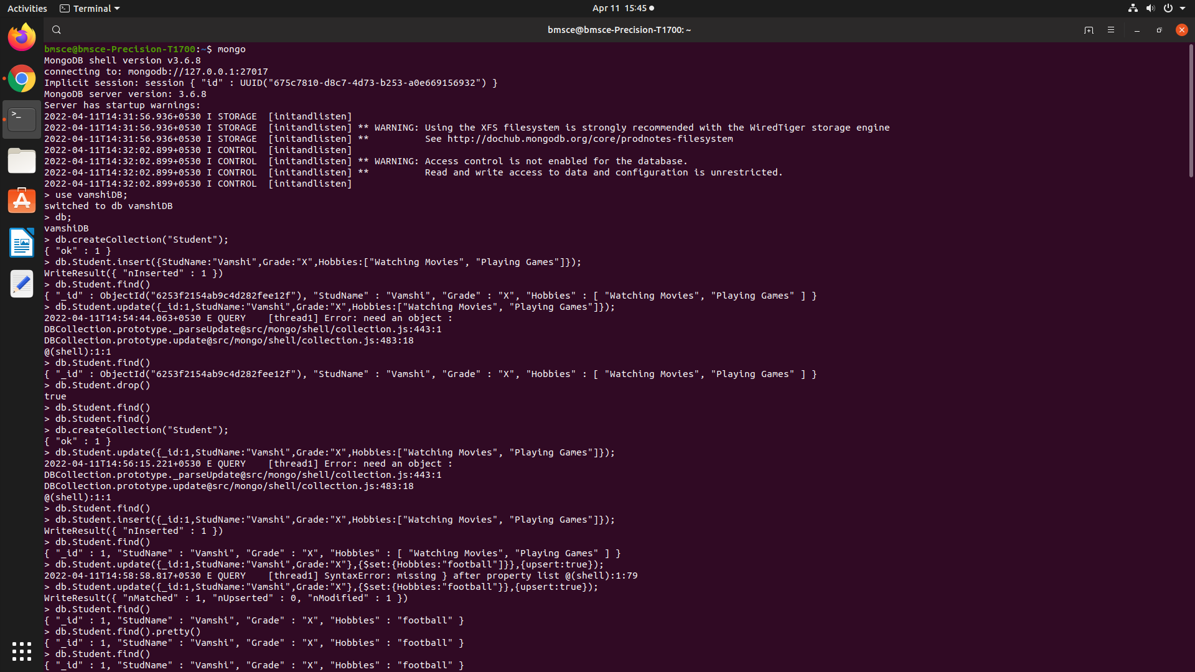

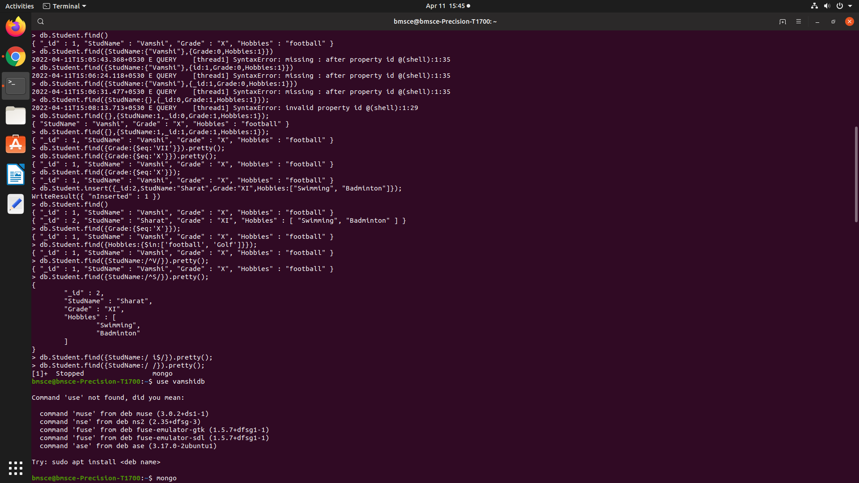

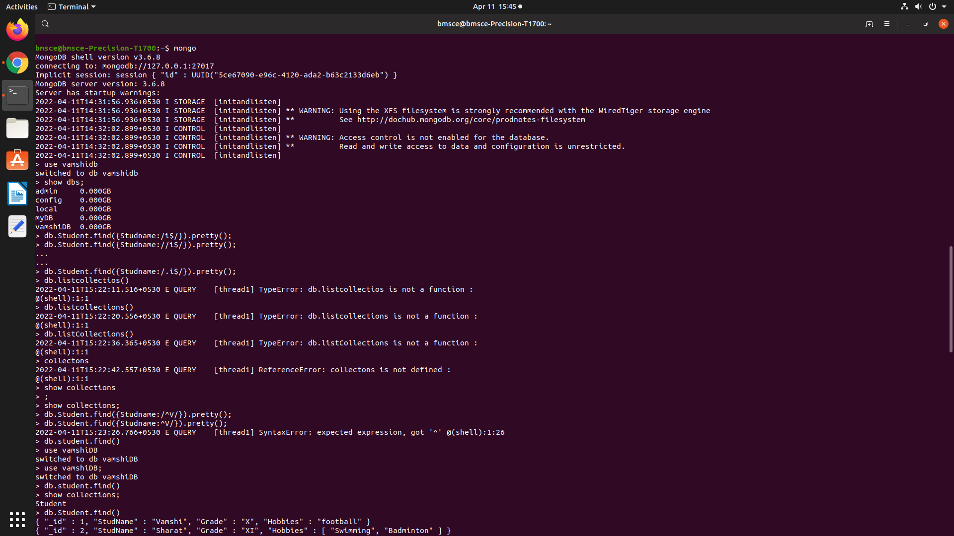

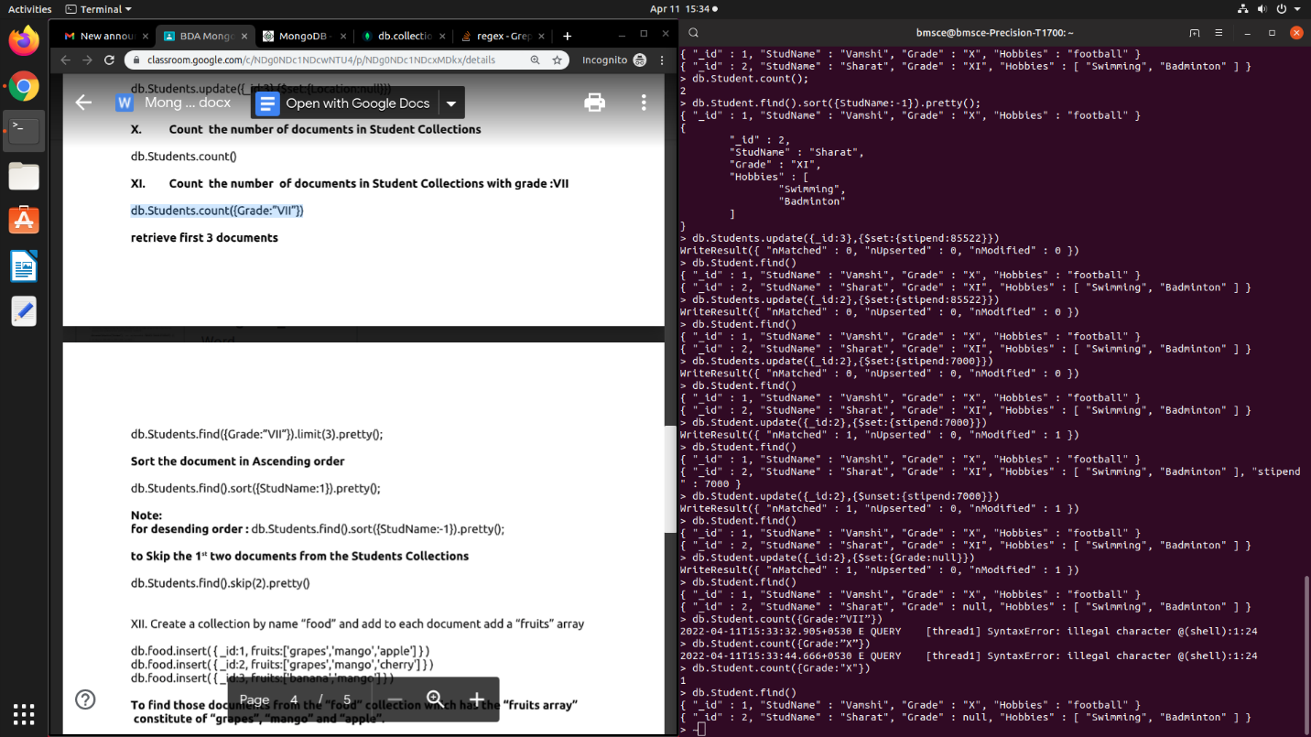

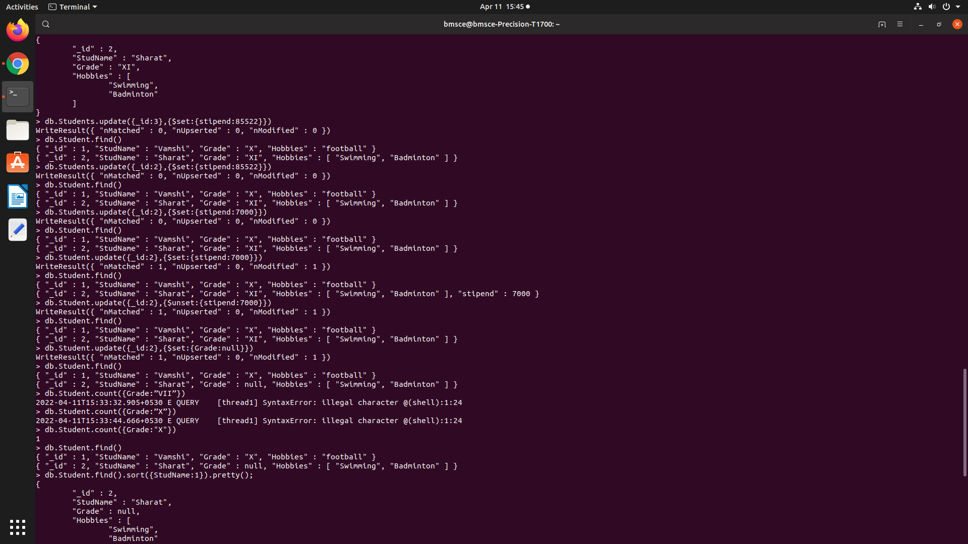

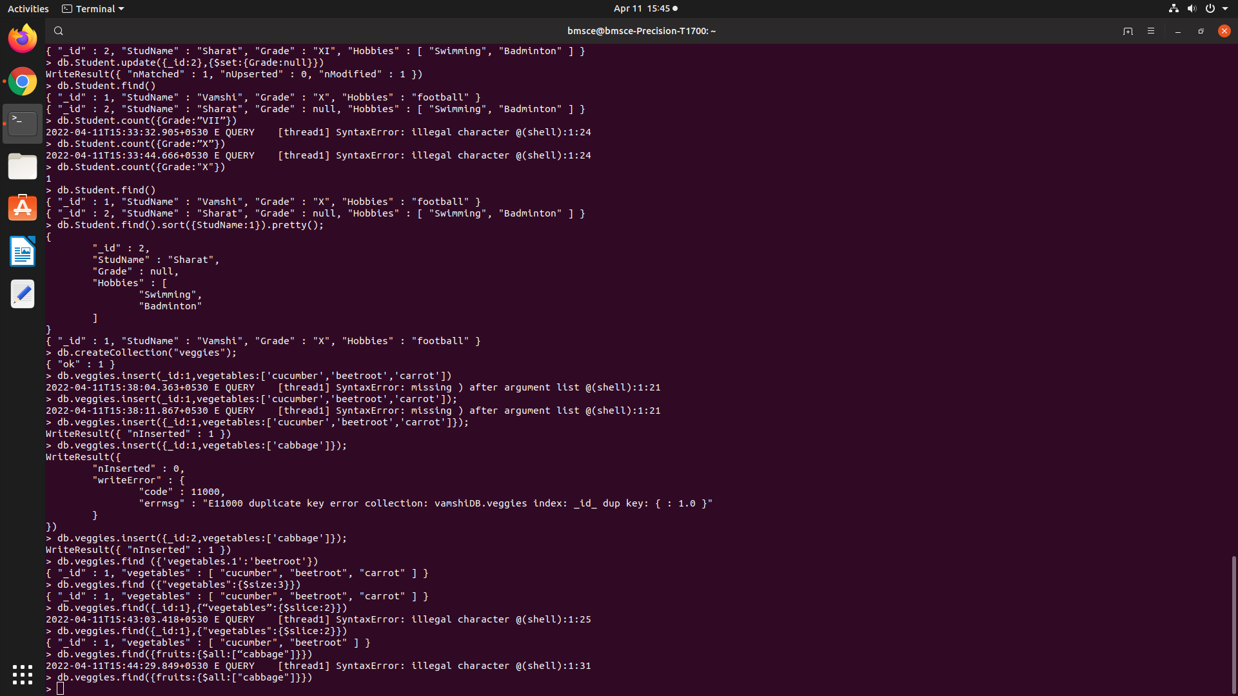

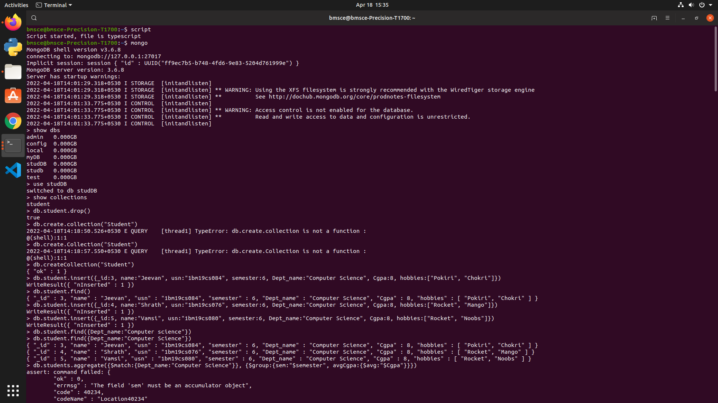

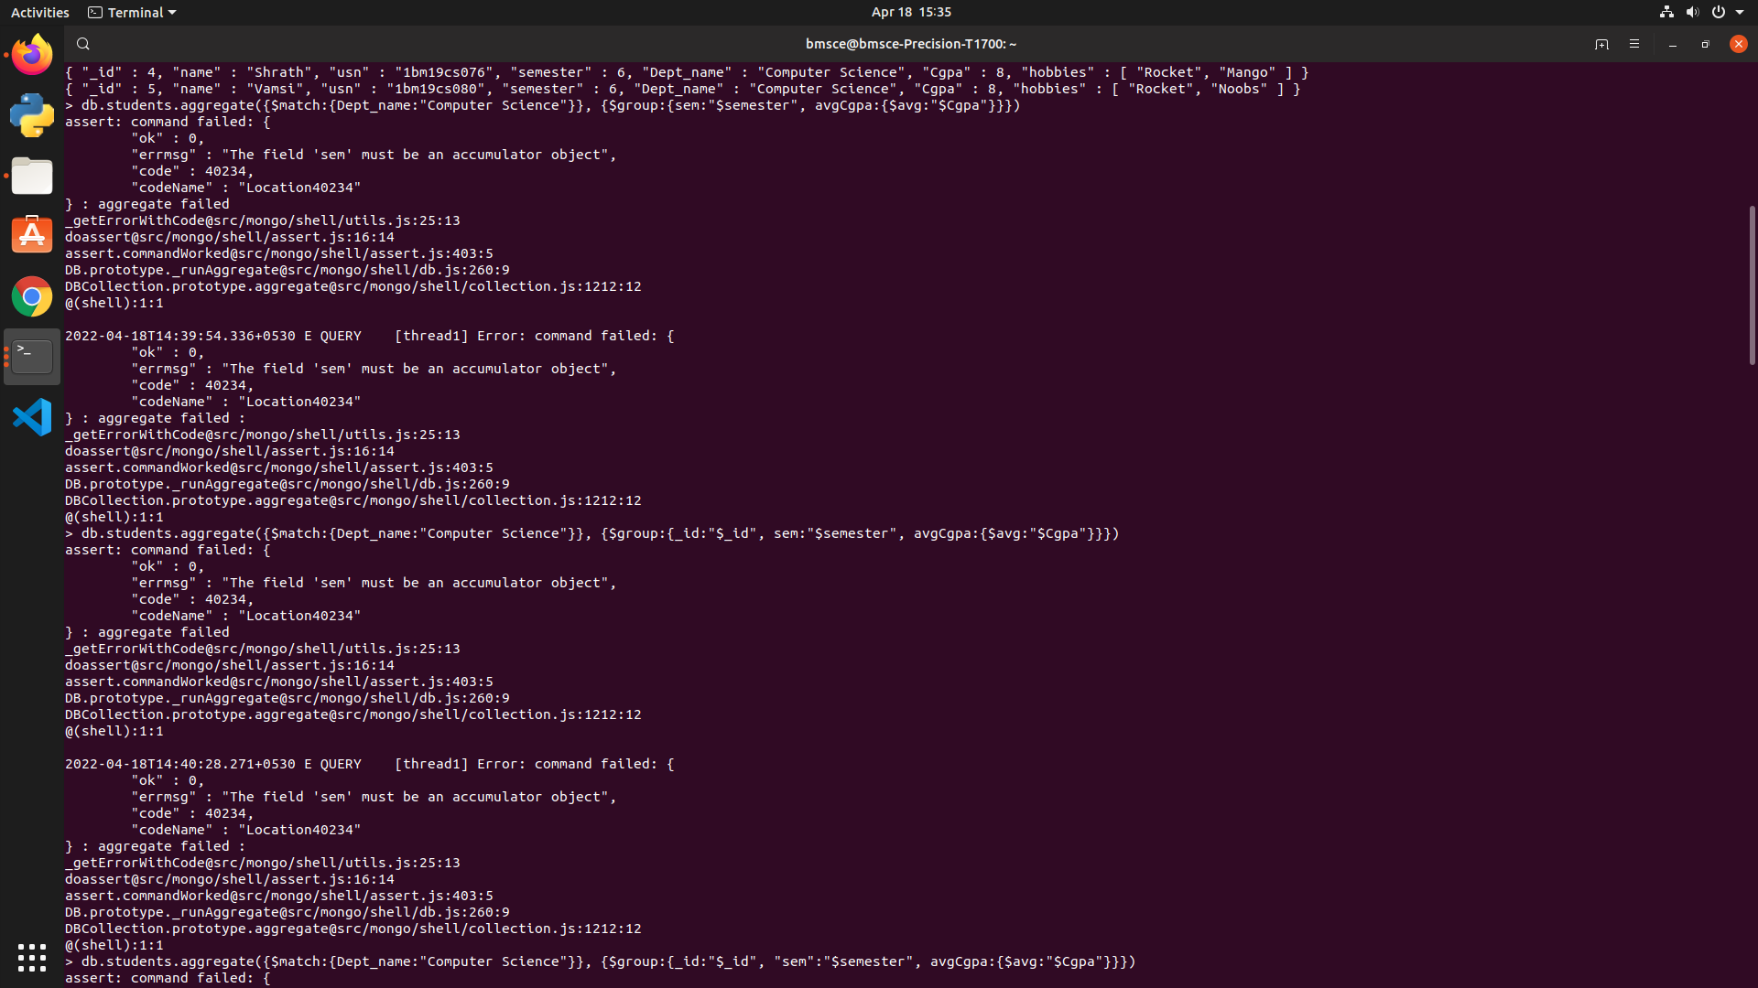

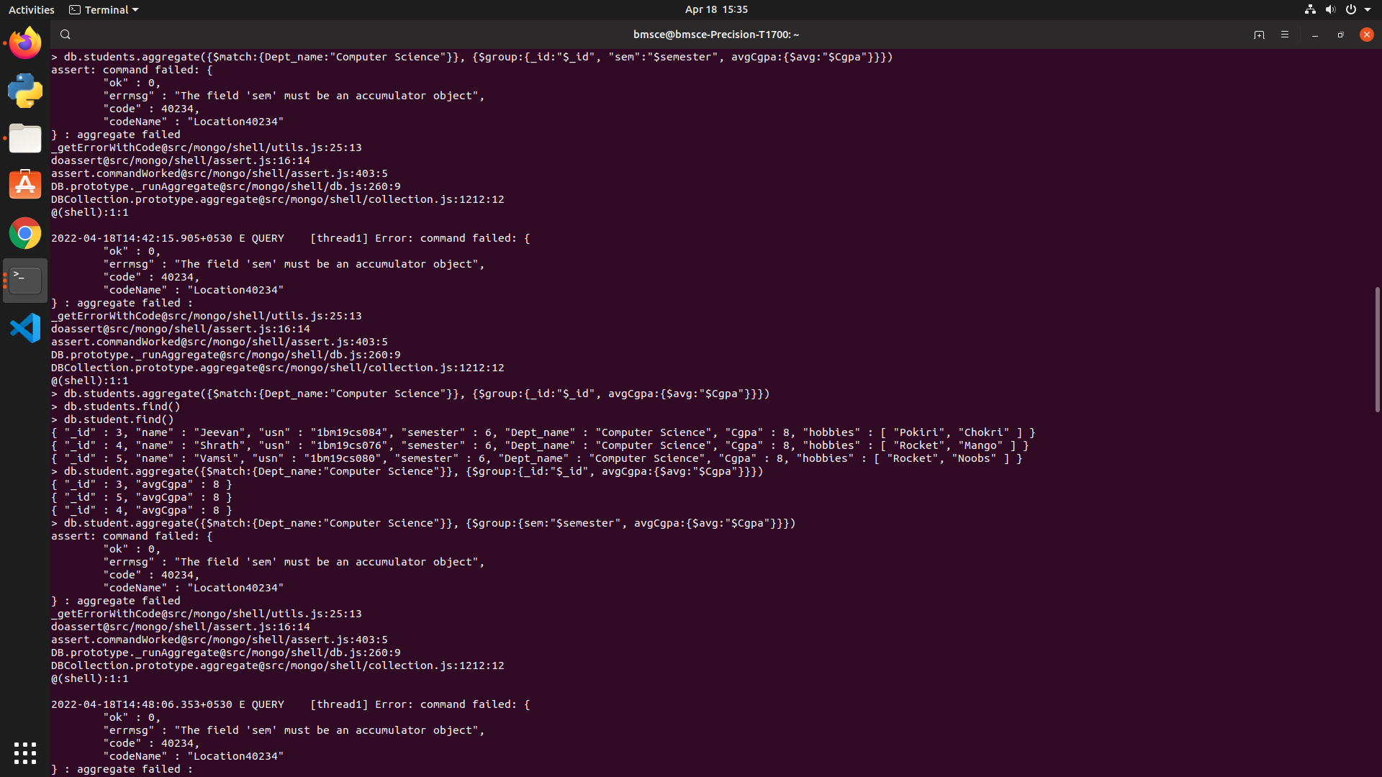

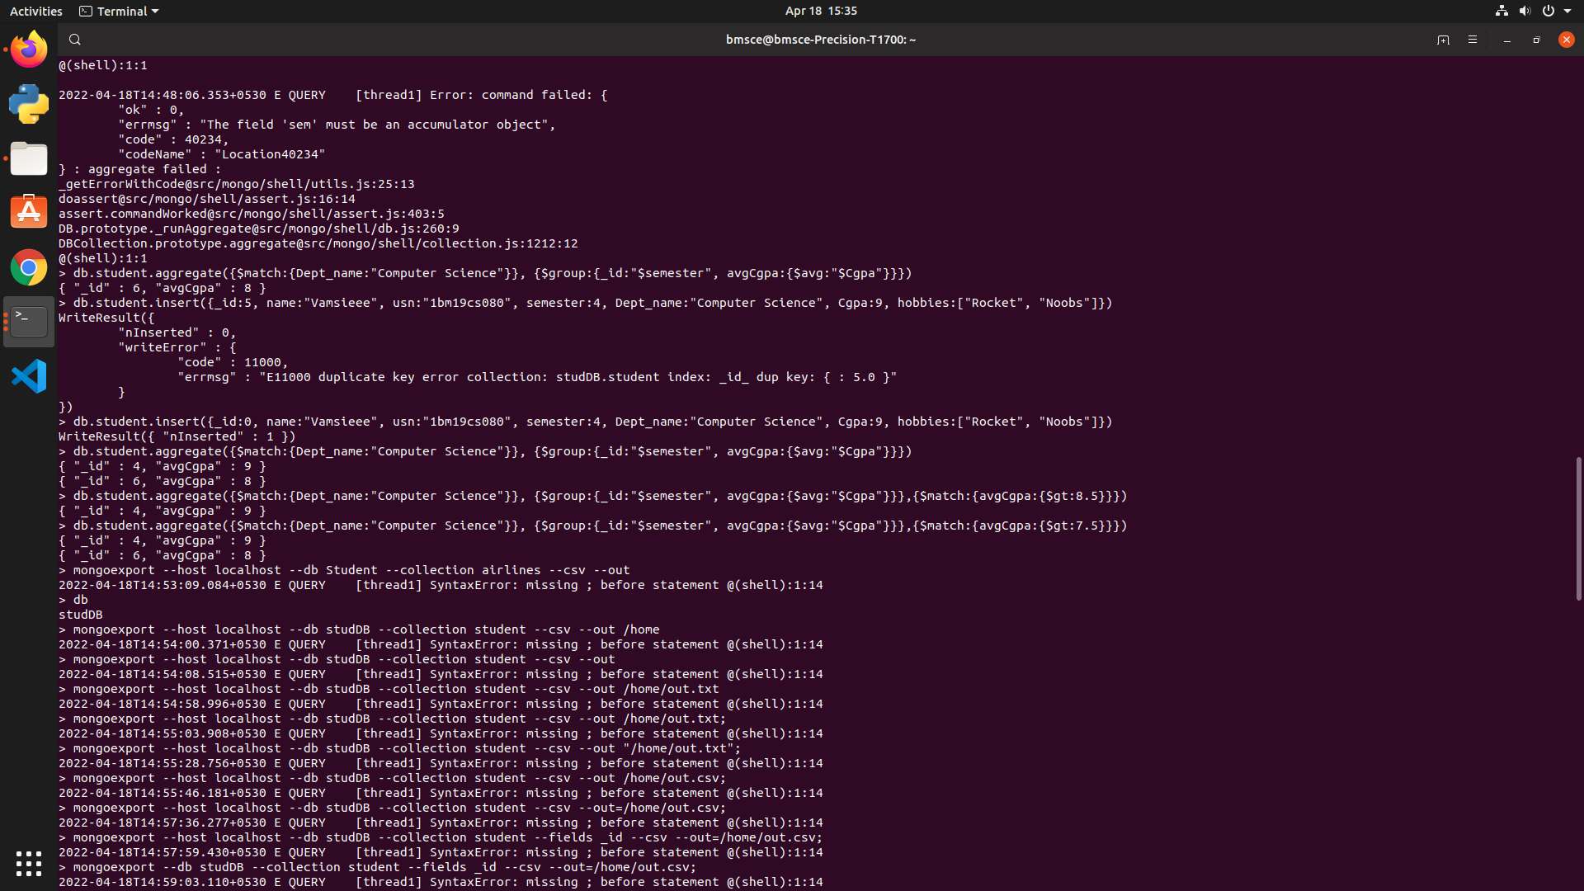

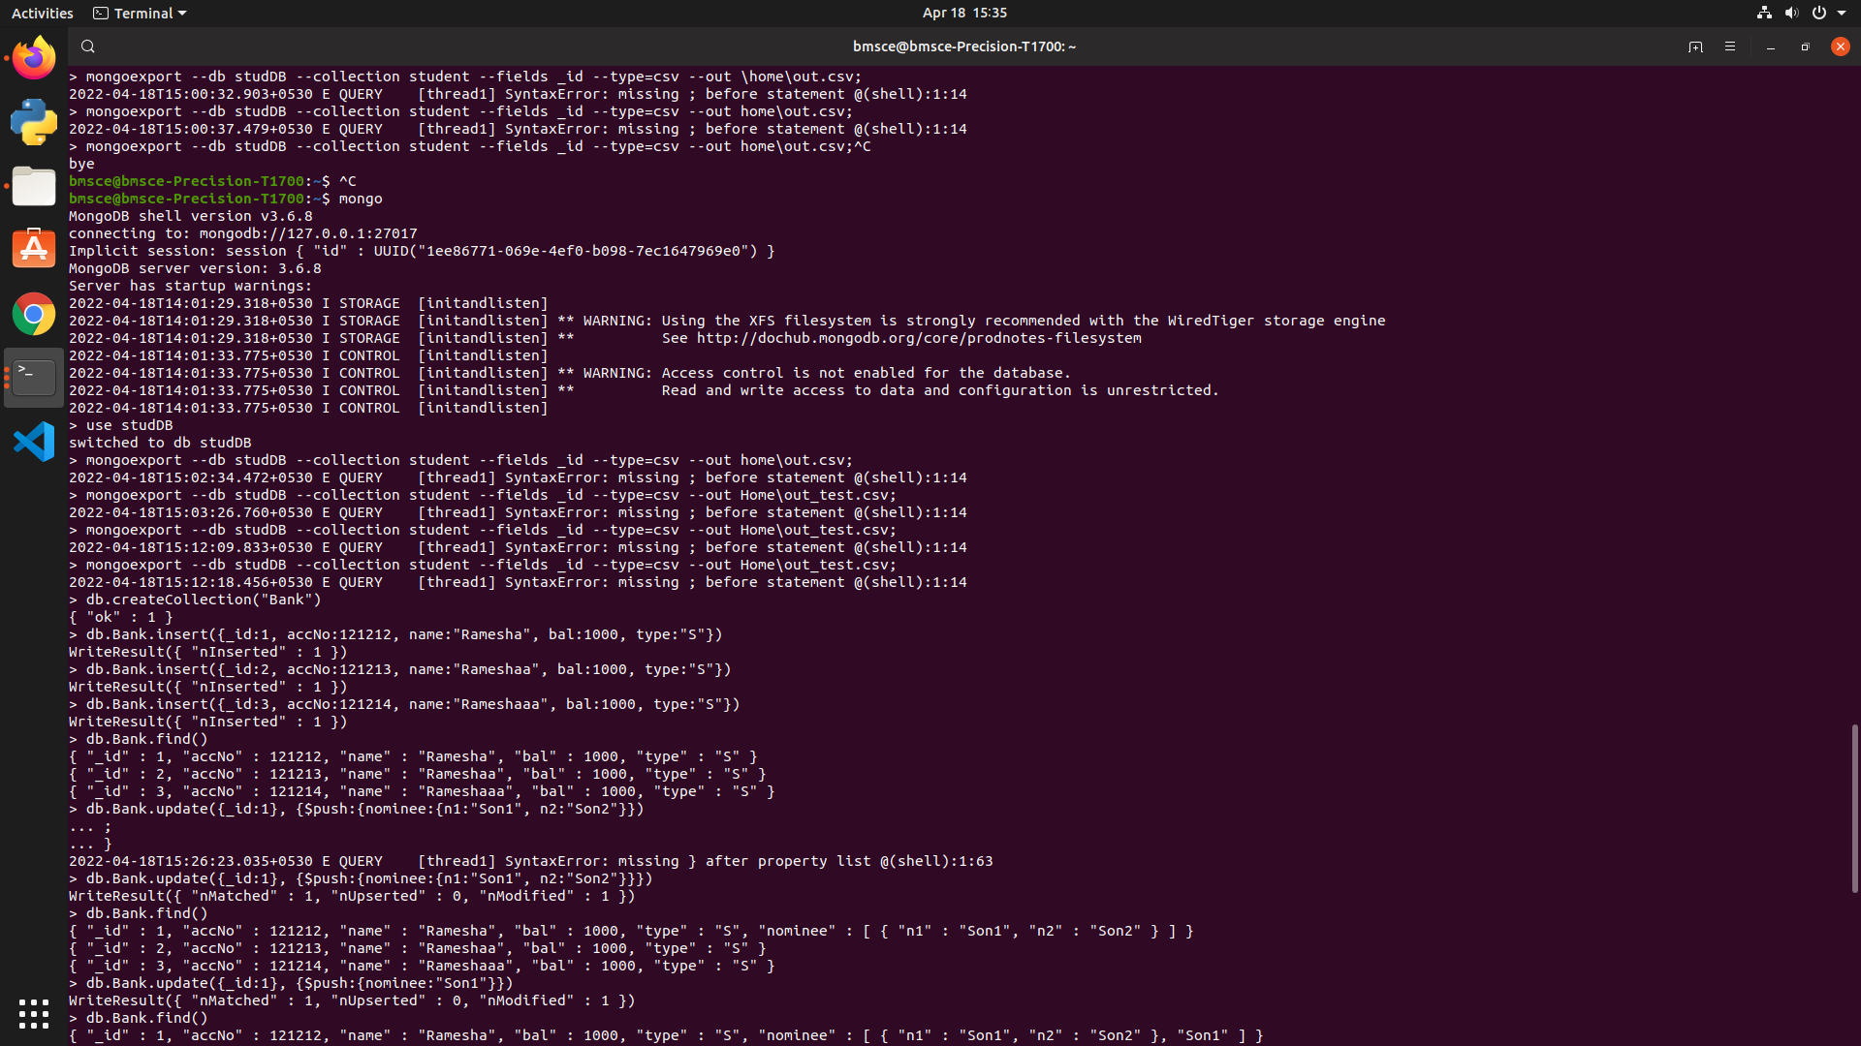



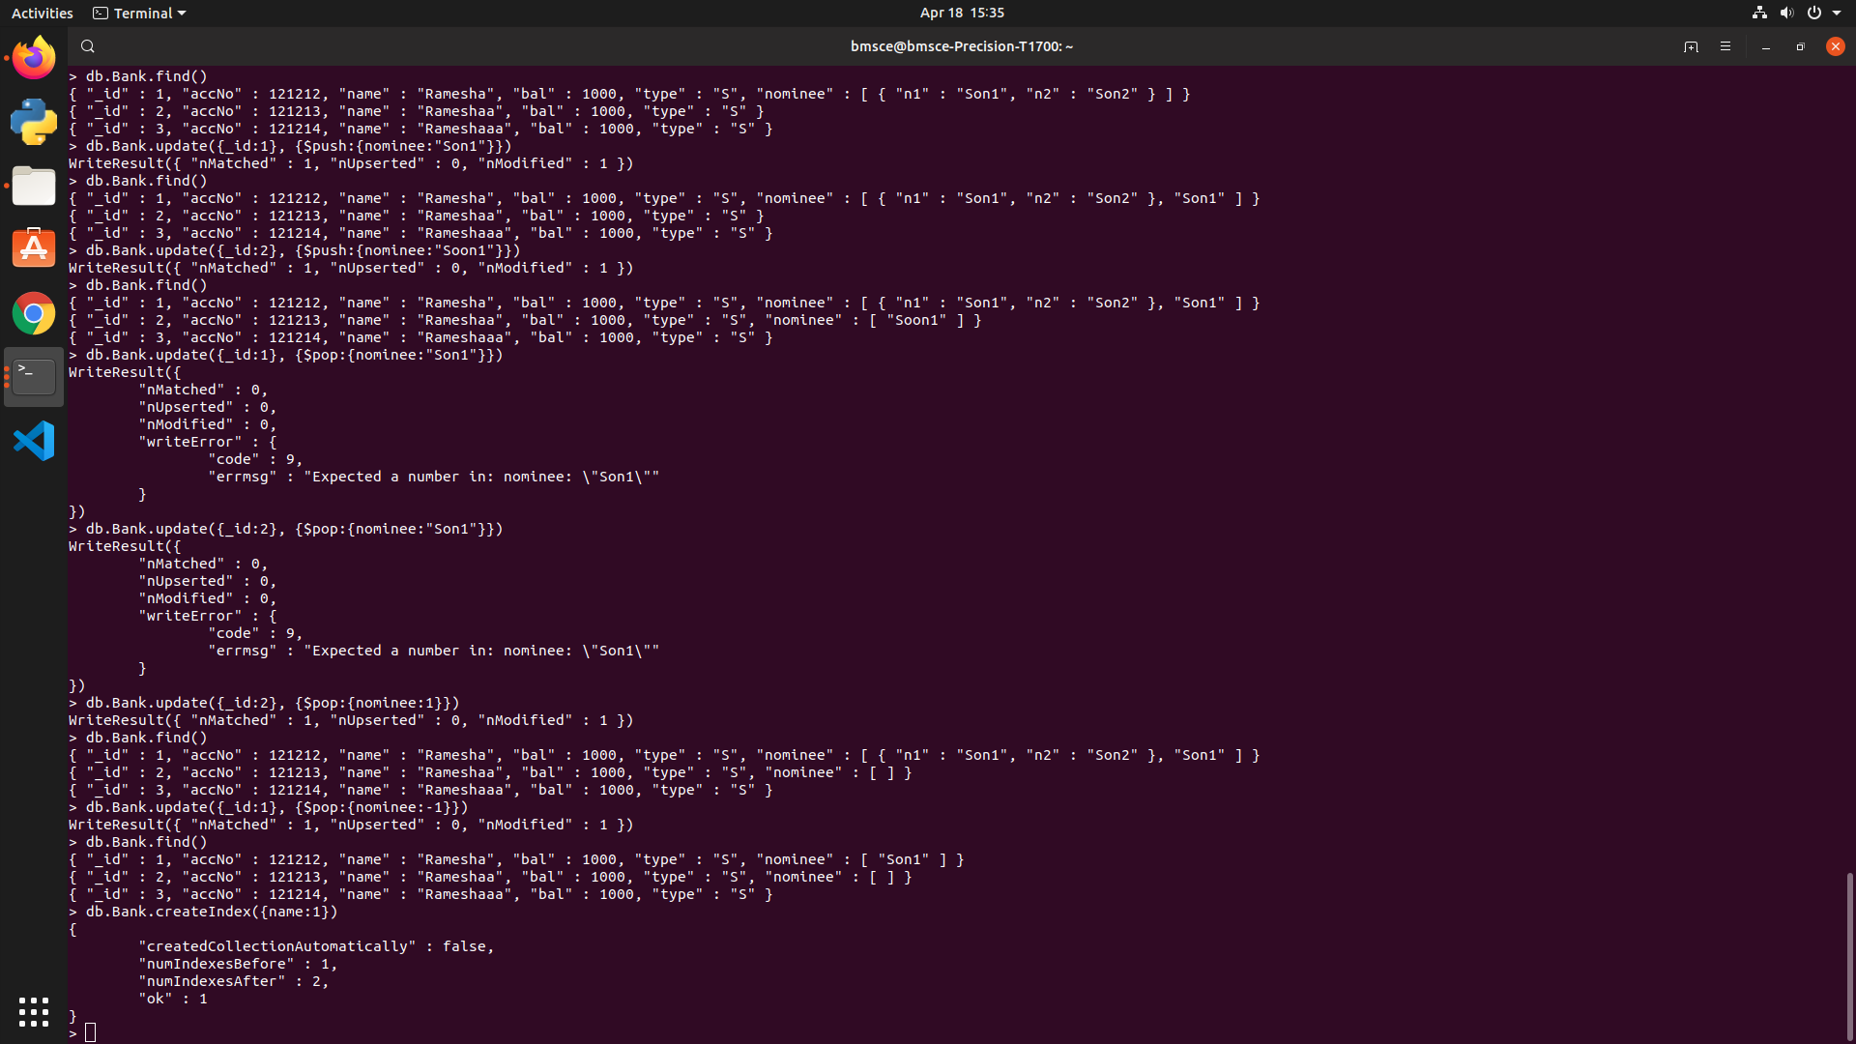

**2.     Perform the following DB operations using Cassandra.**

1.Create a keyspace by name Employee

2. Create a column family by name Employee-Info

with attributes

Emp_Id Primary Key, Emp_Name,

Designation, Date_of_Joining, Salary,

Dept_Name

3. Insert the values into the table in batch

4. Update Employee name and Department of Emp-Id 121

5. Sort the details of Employee records based on salary

6. Alter the schema of the table Employee_Info to add a column Projects which

stores a set of Projects done by the corresponding Employee.

7. Update the altered table to add project names.

8.Create a TTL of 15 seconds to display the values of Employee

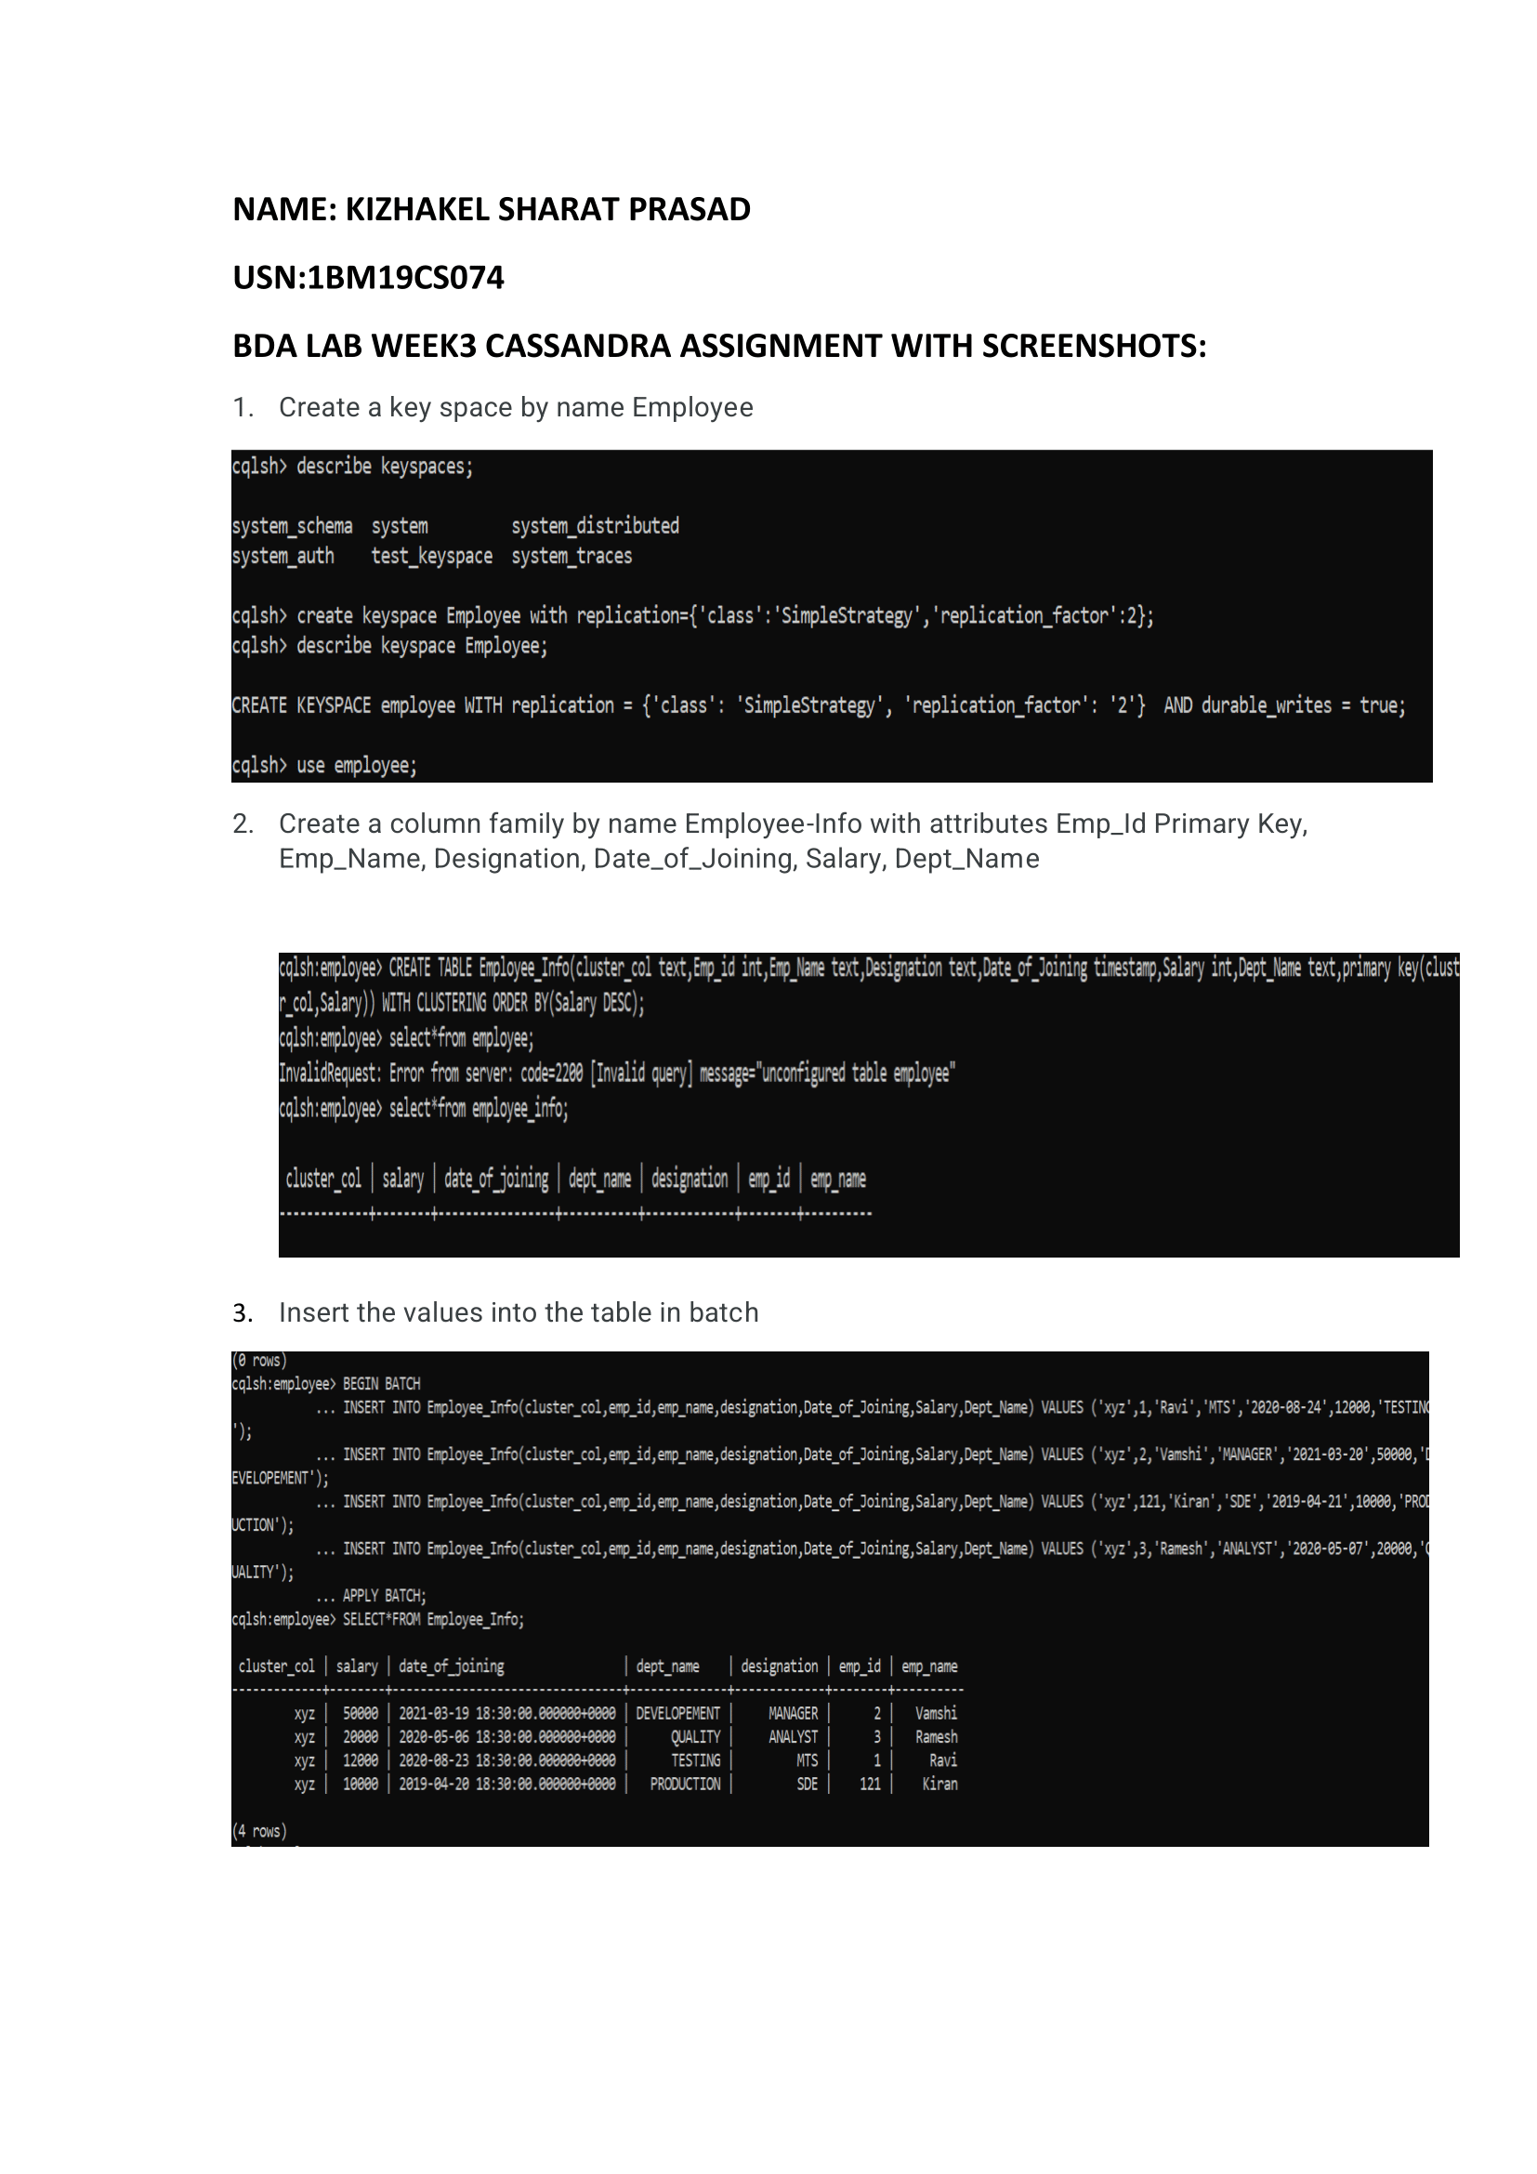

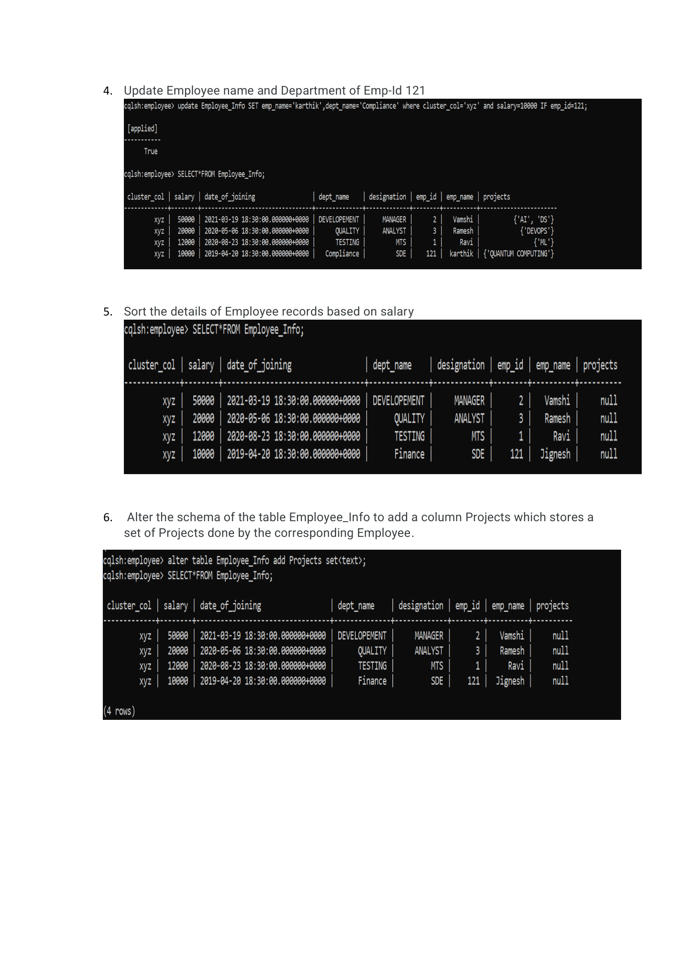

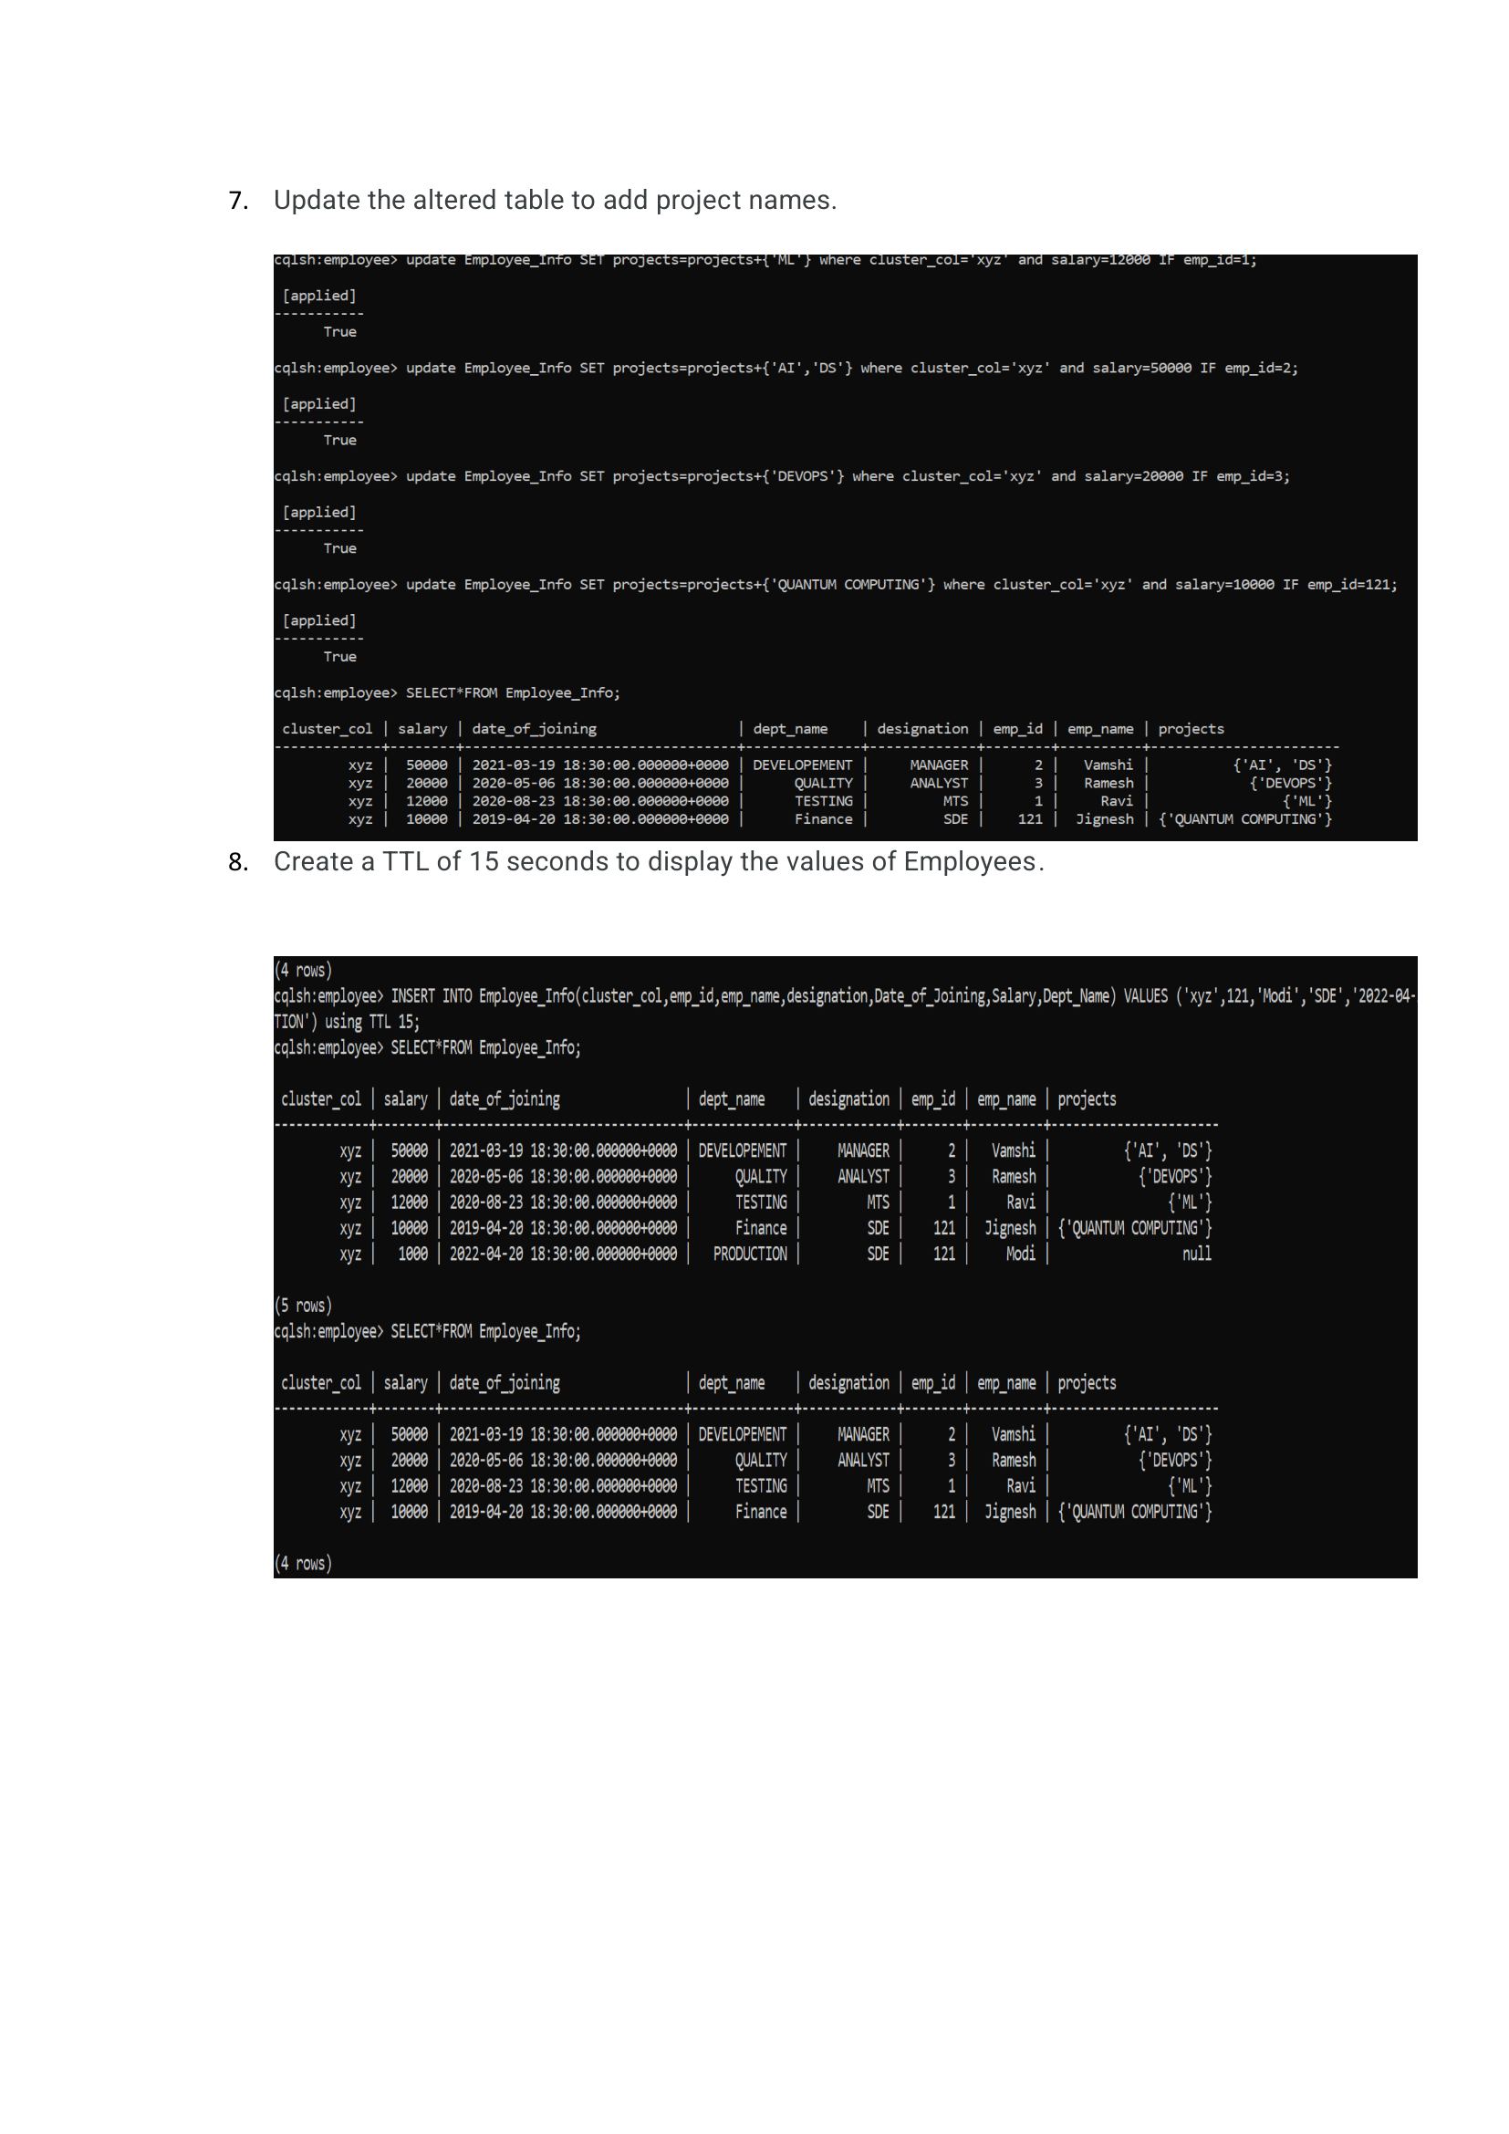

**3.    Perform the following DB operations using Cassandra.**

             1.Create a keyspace by name Library

             2. Create a column family by name Library-Info with attributes

                     Stud_Id Primary Key,

                     Counter_value of type Counter,

                     Stud_Name, Book-Name, Book-Id,

                     Date_of_issue

             3. Insert the values into the table in batch

             4. Display the details of the table created and increase the value of the counter

             5. Write a query to show that a student with id 112 has taken a book “BDA” 2 times.

             6. Export the created column to a csv file

             7. Import a given csv dataset from local file system into Cassandra column family

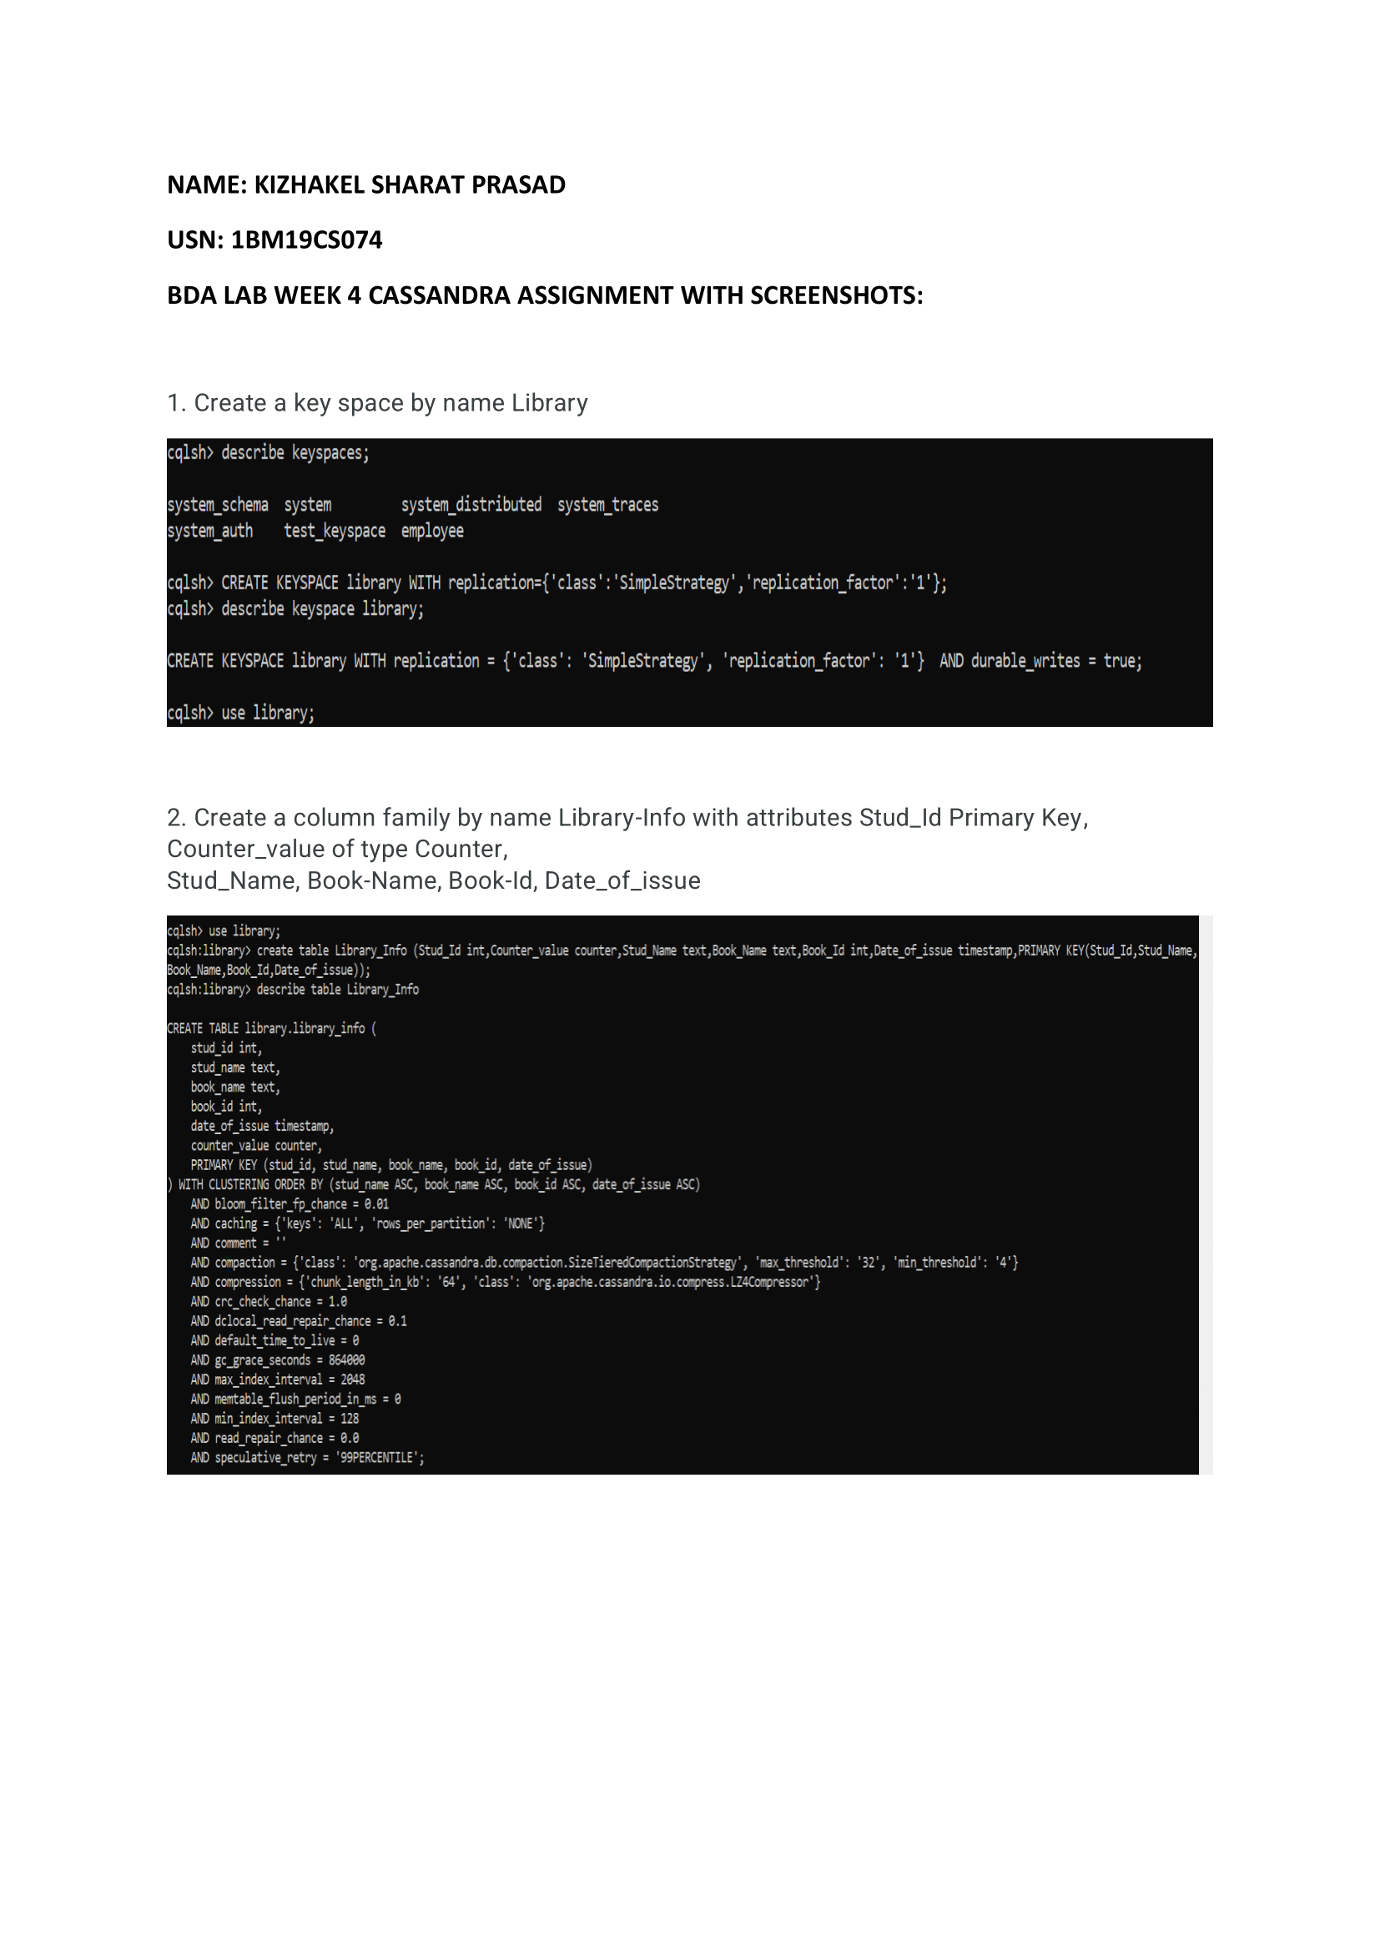

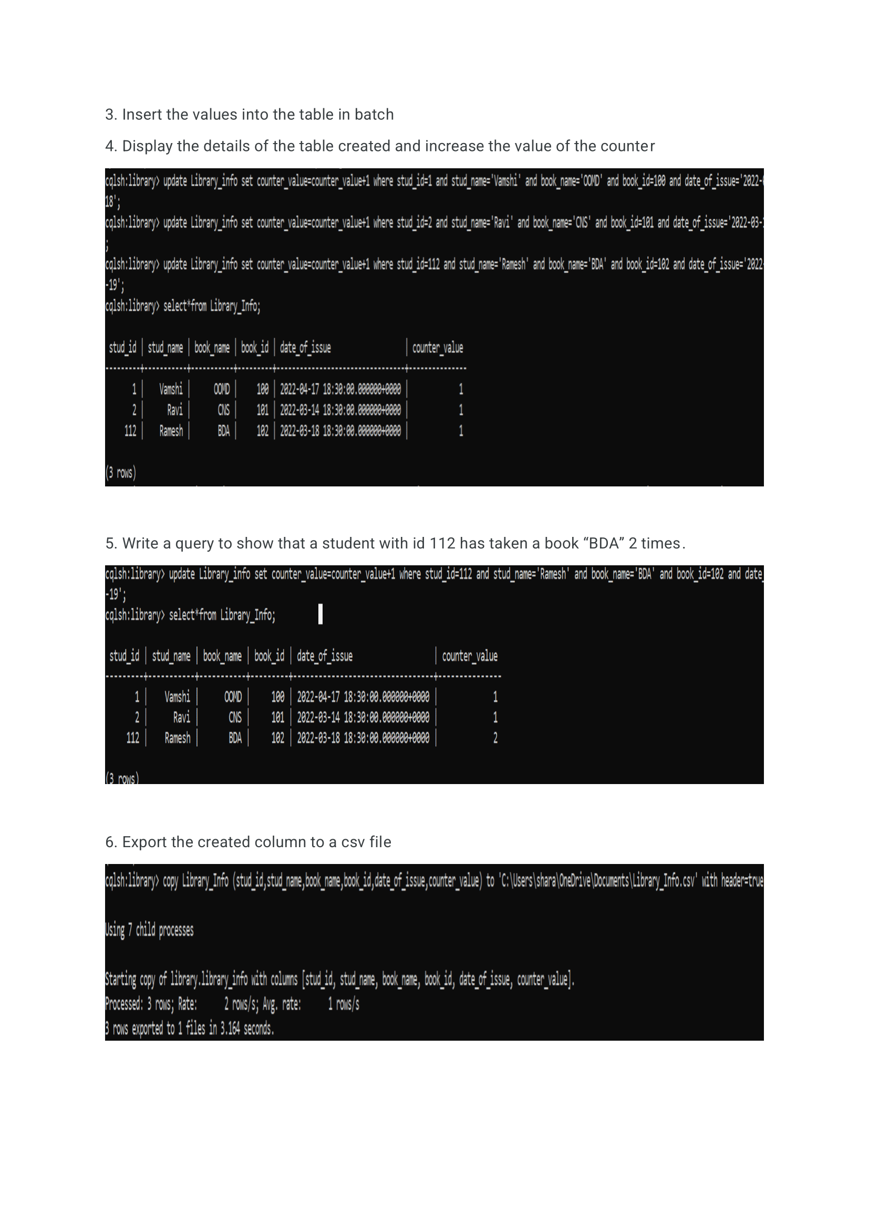

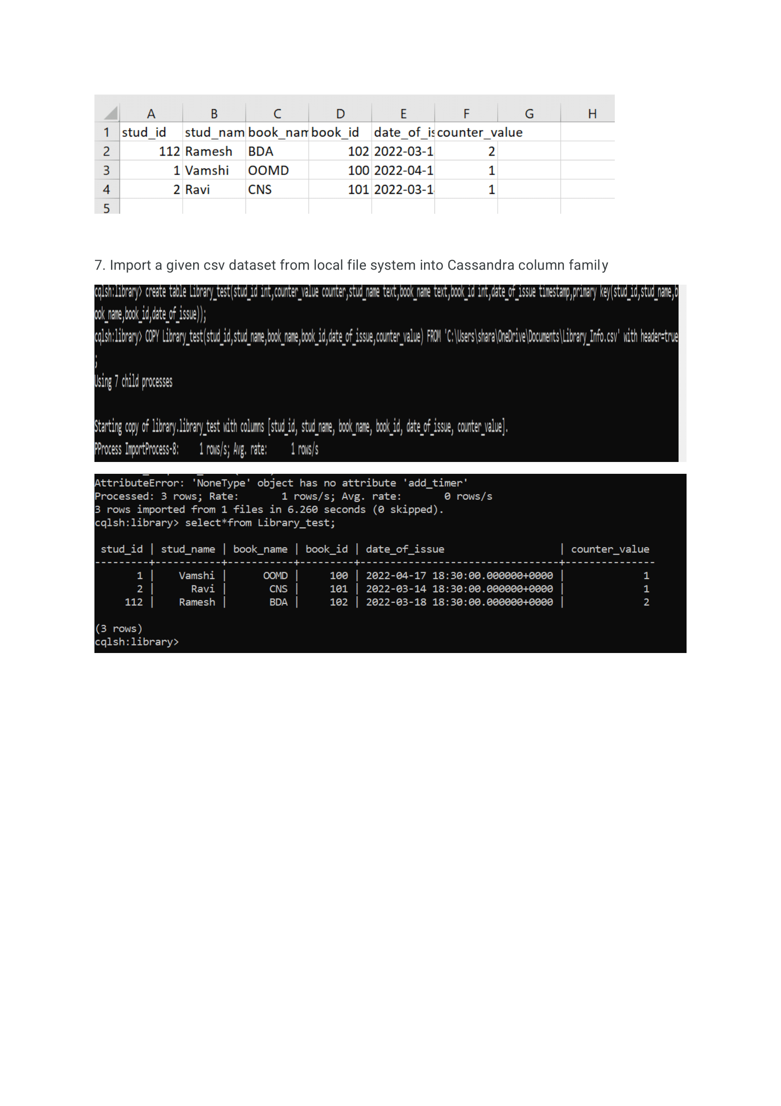**4.   Execution of HDFS Commands for interaction with Hadoop Environment.**

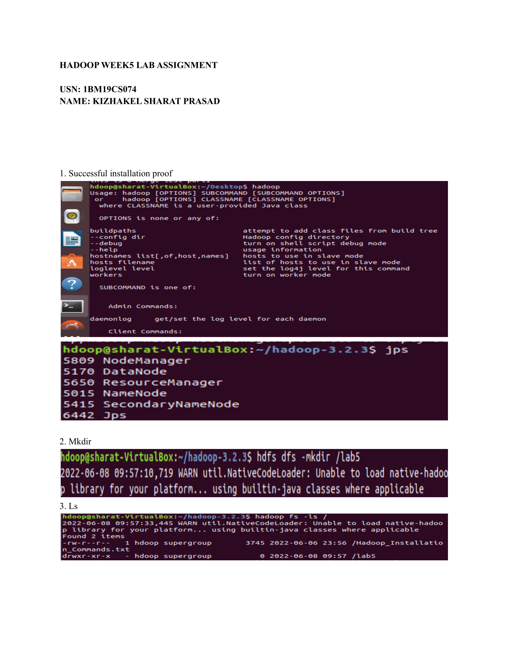

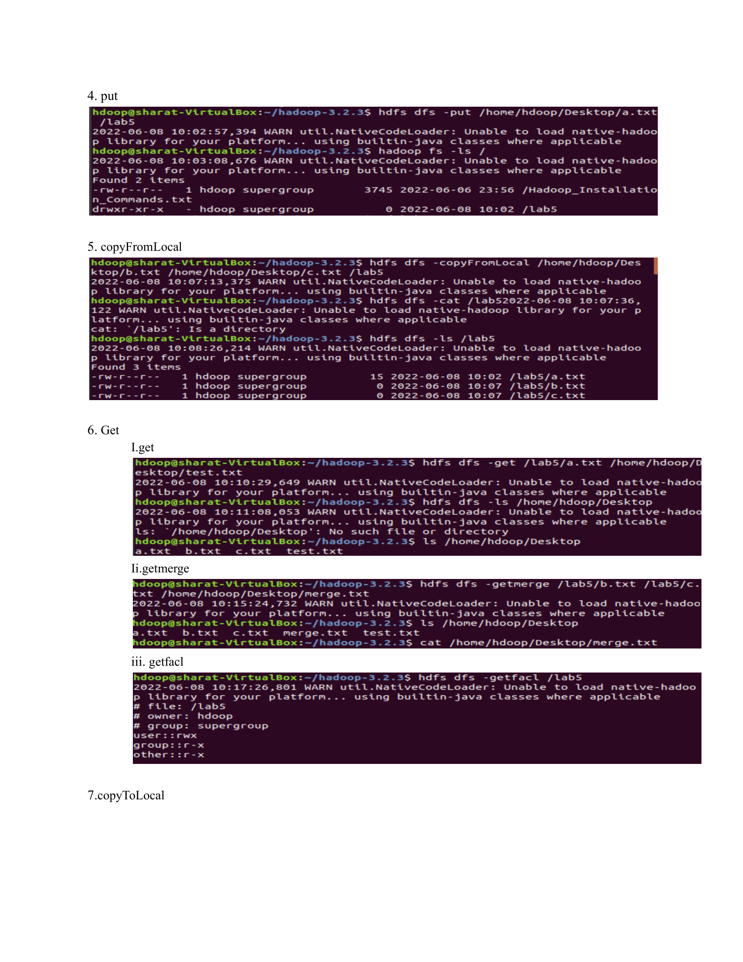

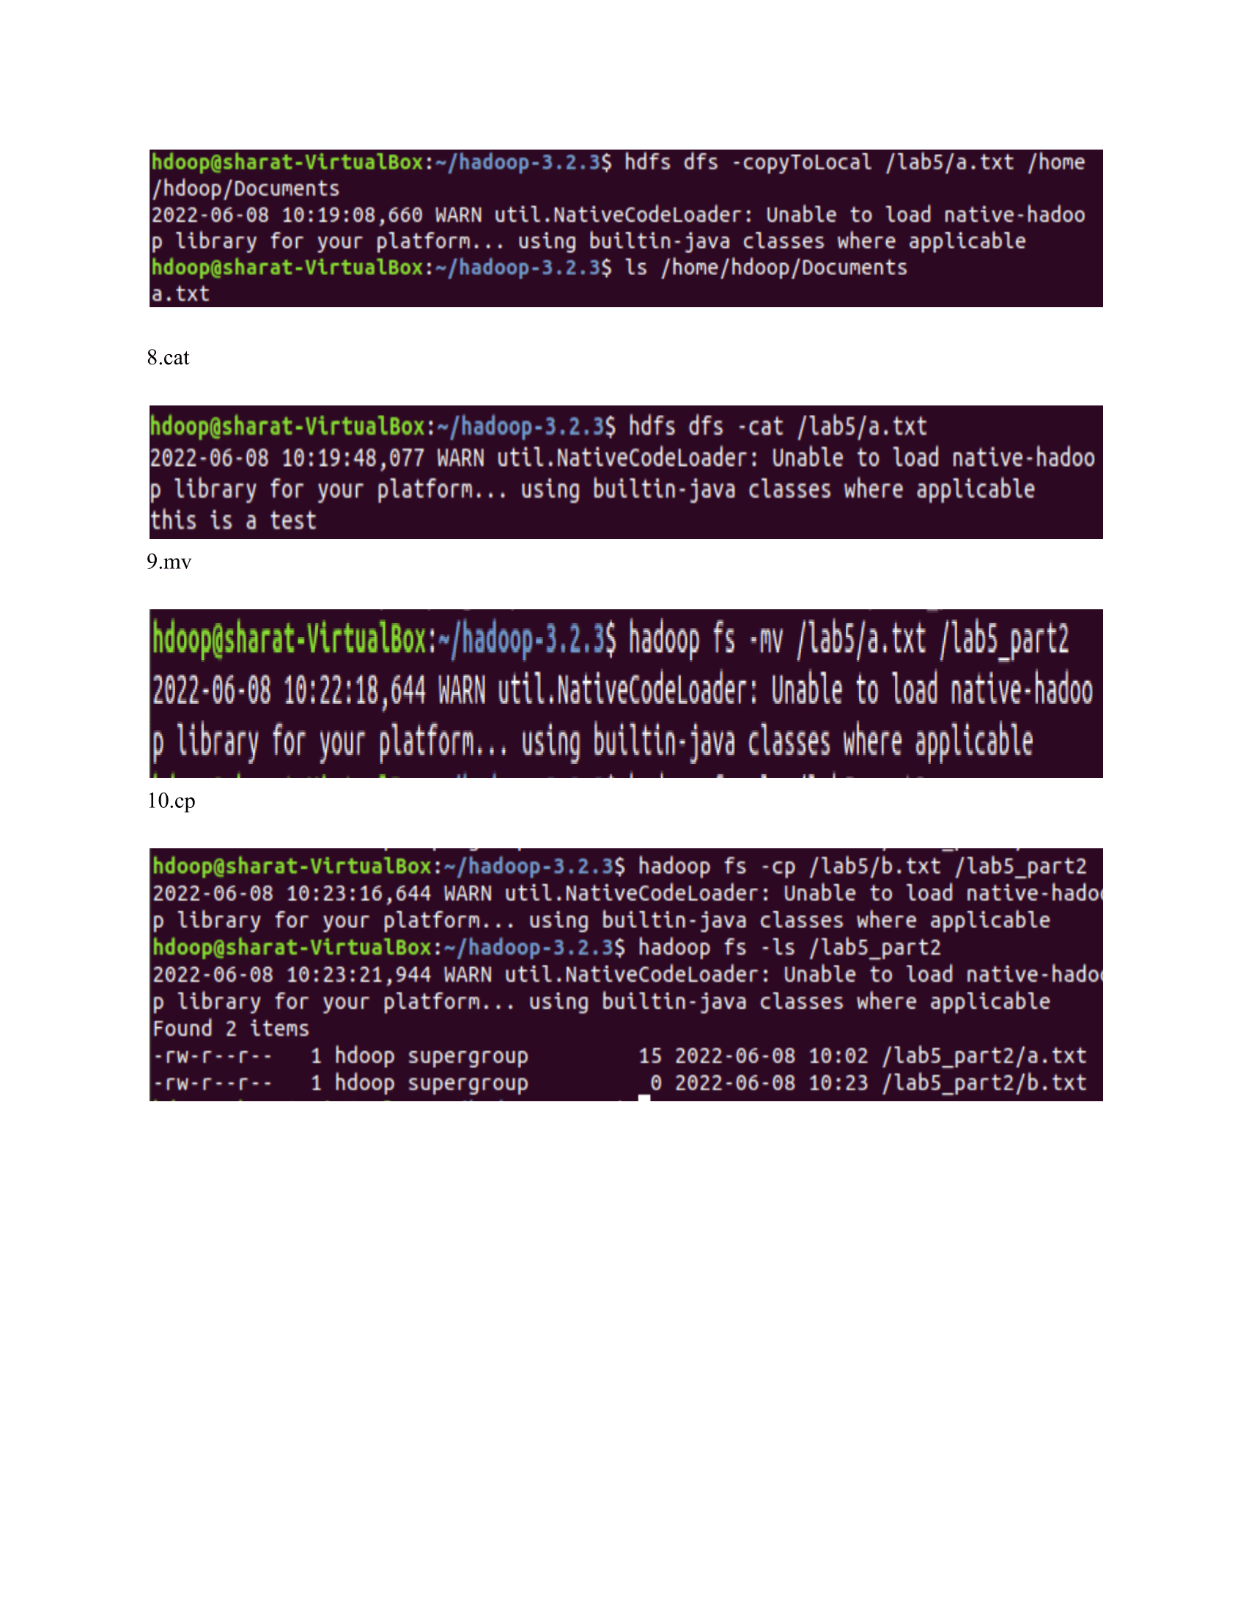

**5. Screenshot of Hadoop installed**

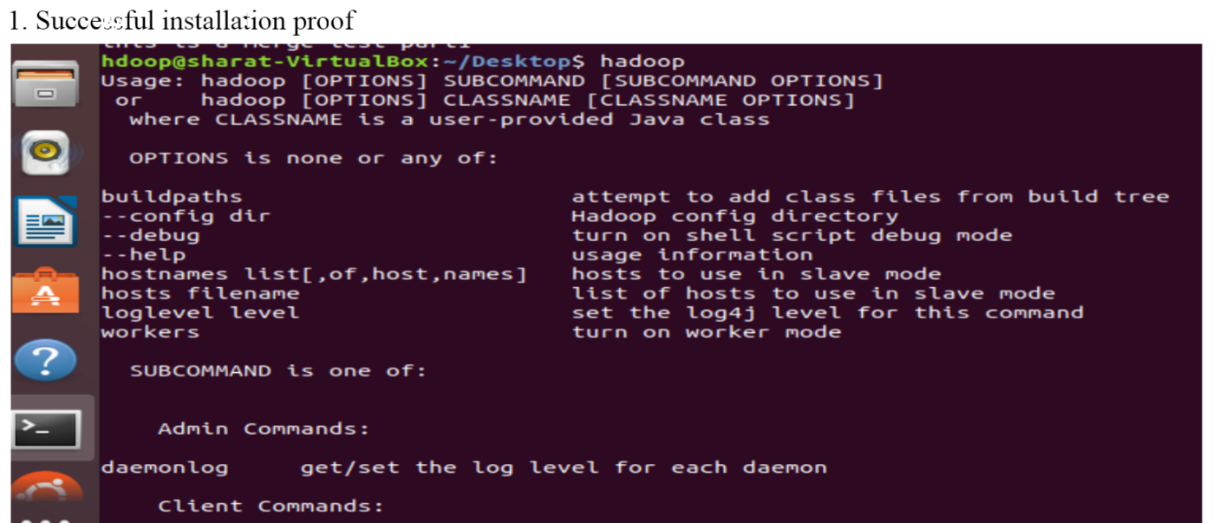

**6. Create a Map Reduce program to**

**a) find average temperature for each year from NCDC data set.**

**b) find the mean max temperature for every month**

a)

CODE:

AverageDriver

**package** temp;  
  
**import** org.apache.hadoop.fs.Path;  
**import** org.apache.hadoop.io.IntWritable;  
**import** org.apache.hadoop.io.Text;  
**import** org.apache.hadoop.mapreduce.Job;  
**import** org.apache.hadoop.mapreduce.lib.input.FileInputFormat;  
**import** org.apache.hadoop.mapreduce.lib.output.FileOutputFormat;  
  
**public** **class** AverageDriver {  
  **public** **static** **void** main(String[] args) **throws** Exception {  
    **if** (args.length != 2) {  
      System.err.println("Please Enter the input and output parameters");  
      System.exit(-1);  
    }   
    Job job = **new** Job();  
    job.setJarByClass(AverageDriver.**class**);  
    job.setJobName("Max temperature");  
    FileInputFormat.addInputPath(job, **new** Path(args[0]));  
    FileOutputFormat.setOutputPath(job, **new** Path(args[1]));  
    job.setMapperClass(AverageMapper.**class**);  
    job.setReducerClass(AverageReducer.**class**);  
    job.setOutputKeyClass(Text.**class**);  
    job.setOutputValueClass(IntWritable.**class**);  
    System.exit(job.waitForCompletion(**true**) ? 0 : 1);  
  }  
}

AverageMapper

**package** temp;  
  
**import** java.io.IOException;  
**import** org.apache.hadoop.io.IntWritable;  
**import** org.apache.hadoop.io.LongWritable;  
**import** org.apache.hadoop.io.Text;  
**import** org.apache.hadoop.mapreduce.Mapper;  
  
**public** **class** AverageMapper **extends** Mapper<LongWritable, Text, Text, IntWritable> {  
  **public** **static** **final** **int** MISSING = 9999;  
    
  **public** **void** map(LongWritable key, Text value, Mapper<LongWritable, Text, Text, IntWritable>.Context context) **throws** IOException, InterruptedException {  
    **int** temperature;  
    String line = value.toString();  
    String year = line.substring(15, 19);  
    **if** (line.charAt(87) == '+') {  
      temperature = Integer.parseInt(line.substring(88, 92));  
    } **else** {  
      temperature = Integer.parseInt(line.substring(87, 92));  
    }   
    String quality = line.substring(92, 93);  
    **if** (temperature != 9999 && quality.matches("[01459]"))  
      context.write(**new** Text(year), **new** IntWritable(temperature));   
  }  
}

AverageReducer

**package** temp;  
  
**import** java.io.IOException;  
**import** org.apache.hadoop.io.IntWritable;  
**import** org.apache.hadoop.io.Text;  
**import** org.apache.hadoop.mapreduce.Reducer;  
  
**public** **class** AverageReducer **extends** Reducer<Text, IntWritable, Text, IntWritable> {  
  **public** **void** reduce(Text key, Iterable<IntWritable> values, Reducer<Text, IntWritable, Text, IntWritable>.Context context) **throws** IOException, InterruptedException {  
    **int** max_temp = 0;  
    **int** count = 0;  
    **for** (IntWritable value : values) {  
      max_temp += value.get();  
      count++;  
    }   
    context.write(key, **new** IntWritable(max_temp / count));  
  }  
}

OUTPUT:

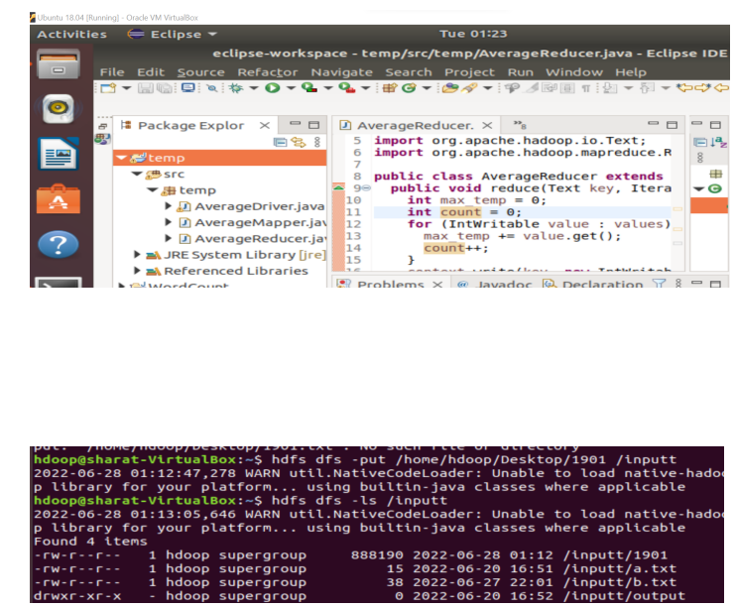

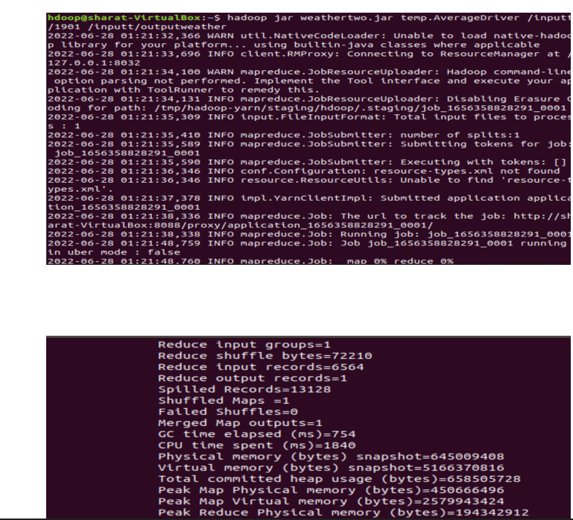

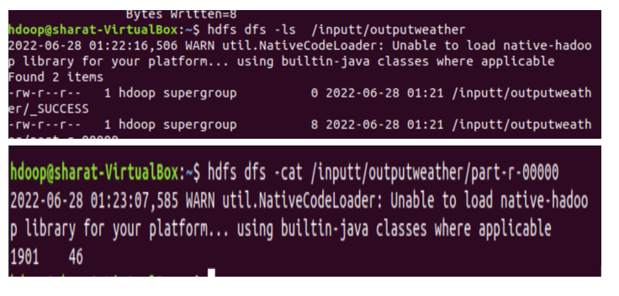

b)

CODE:

MeanMaxDriver.class

**package** meanmax;  
  
**import** org.apache.hadoop.fs.Path;  
**import** org.apache.hadoop.io.IntWritable;  
**import** org.apache.hadoop.io.Text;  
**import** org.apache.hadoop.mapreduce.Job;  
**import** org.apache.hadoop.mapreduce.lib.input.FileInputFormat;  
**import** org.apache.hadoop.mapreduce.lib.output.FileOutputFormat;  
  
**public** **class** MeanMaxDriver {  
  **public** **static** **void** main(String[] args) **throws** Exception {  
    **if** (args.length != 2) {  
      System.err.println("Please Enter the input and output parameters");  
      System.exit(-1);  
    }   
    Job job = **new** Job();  
    job.setJarByClass(MeanMaxDriver.**class**);  
    job.setJobName("Max temperature");  
    FileInputFormat.addInputPath(job, **new** Path(args[0]));  
    FileOutputFormat.setOutputPath(job, **new** Path(args[1]));  
    job.setMapperClass(MeanMaxMapper.**class**);  
    job.setReducerClass(MeanMaxReducer.**class**);  
    job.setOutputKeyClass(Text.**class**);  
    job.setOutputValueClass(IntWritable.**class**);  
    System.exit(job.waitForCompletion(**true**) ? 0 : 1);  
  }  
}  
  
MeanMaxMapper.class

**package** meanmax;  
  
**import** java.io.IOException;  
**import** org.apache.hadoop.io.IntWritable;  
**import** org.apache.hadoop.io.LongWritable;  
**import** org.apache.hadoop.io.Text;  
**import** org.apache.hadoop.mapreduce.Mapper;  
  
**public** **class** MeanMaxMapper **extends** Mapper<LongWritable, Text, Text, IntWritable> {  
  **public** **static** **final** **int** MISSING = 9999;  
    
  **public** **void** map(LongWritable key, Text value, Mapper<LongWritable, Text, Text, IntWritable>.Context context) **throws** IOException, InterruptedException {  
    **int** temperature;  
    String line = value.toString();  
    String month = line.substring(19, 21);  
    **if** (line.charAt(87) == '+') {  
      temperature = Integer.parseInt(line.substring(88, 92));  
    } **else** {  
      temperature = Integer.parseInt(line.substring(87, 92));  
    }   
    String quality = line.substring(92, 93);  
    **if** (temperature != 9999 && quality.matches("[01459]"))  
      context.write(**new** Text(month), **new** IntWritable(temperature));   
  }  
}  
  
MeanMaxReducer.class

**package** meanmax;  
  
**import** java.io.IOException;  
**import** org.apache.hadoop.io.IntWritable;  
**import** org.apache.hadoop.io.Text;  
**import** org.apache.hadoop.mapreduce.Reducer;  
  
**public** **class** MeanMaxReducer **extends** Reducer<Text, IntWritable, Text, IntWritable> {  
  **public** **void** reduce(Text key, Iterable<IntWritable> values, Reducer<Text, IntWritable, Text, IntWritable>.Context context) **throws** IOException, InterruptedException {  
    **int** max_temp = 0;  
    **int** total_temp = 0;  
    **int** count = 0;  
    **int** days = 0;  
    **for** (IntWritable value : values) {  
      **int** temp = value.get();  
      **if** (temp > max_temp)  
        max_temp = temp;   
      count++;  
      **if** (count == 3) {  
        total_temp += max_temp;  
        max_temp = 0;  
        count = 0;  
        days++;  
      }   
    }   
    context.write(key, **new** IntWritable(total_temp / days));  
  }  
}

OUTPUT:

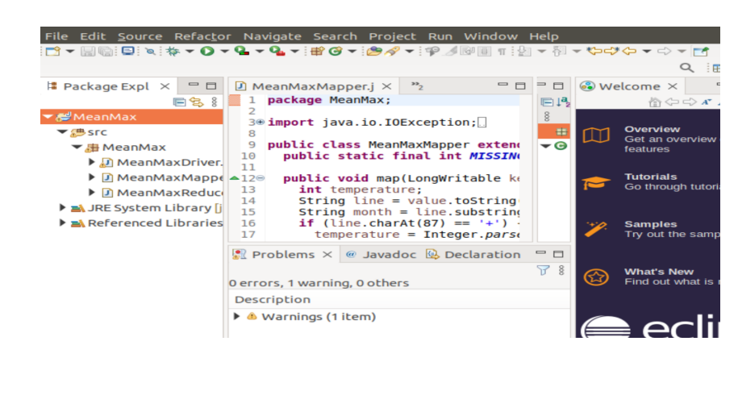

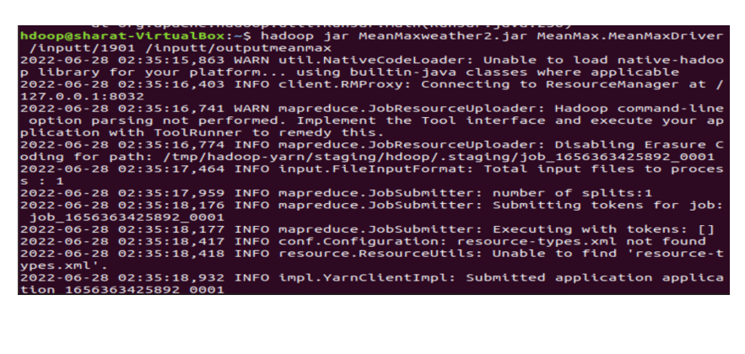

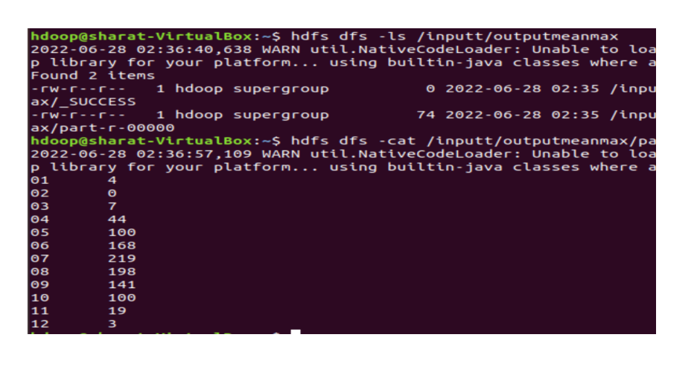

**7. For a given Text file, Create a Map Reduce program to sort the content in an alphabetic order listing only top 10 maximum occurrences of words.**

CODE:

Driver-TopN.class

**package** samples.topn;  
  
**import** java.io.IOException;  
**import** java.util.StringTokenizer;  
**import** org.apache.hadoop.conf.Configuration;  
**import** org.apache.hadoop.fs.Path;  
**import** org.apache.hadoop.io.IntWritable;  
**import** org.apache.hadoop.io.Text;  
**import** org.apache.hadoop.mapreduce.Job;  
**import** org.apache.hadoop.mapreduce.Mapper;  
**import** org.apache.hadoop.mapreduce.lib.input.FileInputFormat;  
**import** org.apache.hadoop.mapreduce.lib.output.FileOutputFormat;  
**import** org.apache.hadoop.util.GenericOptionsParser;  
  
**public** **class** TopN {  
  **public** **static** **void** main(String[] args) **throws** Exception {  
    Configuration conf = **new** Configuration();  
    String[] otherArgs = (**new** GenericOptionsParser(conf, args)).getRemainingArgs();  
    **if** (otherArgs.length != 2) {  
      System.err.println("Usage: TopN <in> <out>");  
      System.exit(2);  
    }   
    Job job = Job.getInstance(conf);  
    job.setJobName("Top N");  
    job.setJarByClass(TopN.**class**);  
    job.setMapperClass(TopNMapper.**class**);  
    job.setReducerClass(TopNReducer.**class**);  
    job.setOutputKeyClass(Text.**class**);  
    job.setOutputValueClass(IntWritable.**class**);  
    FileInputFormat.addInputPath(job, **new** Path(otherArgs[0]));  
    FileOutputFormat.setOutputPath(job, **new** Path(otherArgs[1]));  
    System.exit(job.waitForCompletion(**true**) ? 0 : 1);  
  }  
    
  **public** **static** **class** TopNMapper **extends** Mapper<Object, Text, Text, IntWritable> {  
    **private** **static** **final** IntWritable one = **new** IntWritable(1);  
      
    **private** Text word = **new** Text();  
      
    **private** String tokens = "[_|$#<>\\^=\\[\\]\\*/\\\\,;,.\\-:()?!\"']";  
      
    **public** **void** map(Object key, Text value, Mapper<Object, Text, Text, IntWritable>.Context context) **throws** IOException, InterruptedException {  
      String cleanLine = value.toString().toLowerCase().replaceAll(**this**.tokens, " ");  
      StringTokenizer itr = **new** StringTokenizer(cleanLine);  
      **while** (itr.hasMoreTokens()) {  
        **this**.word.set(itr.nextToken().trim());  
        context.write(**this**.word, one);  
      }   
    }  
  }  
}

TopNCombiner.class

**package** samples.topn;  
  
**import** java.io.IOException;  
**import** org.apache.hadoop.io.IntWritable;  
**import** org.apache.hadoop.io.Text;  
**import** org.apache.hadoop.mapreduce.Reducer;  
  
**public** **class** TopNCombiner **extends** Reducer<Text, IntWritable, Text, IntWritable> {  
  **public** **void** reduce(Text key, Iterable<IntWritable> values, Reducer<Text, IntWritable, Text, IntWritable>.Context context) **throws** IOException, InterruptedException {  
    **int** sum = 0;  
    **for** (IntWritable val : values)  
      sum += val.get();   
    context.write(key, **new** IntWritable(sum));  
  }  
}

TopNMapper.class

**package** samples.topn;  
  
**import** java.io.IOException;  
**import** java.util.StringTokenizer;  
**import** org.apache.hadoop.io.IntWritable;  
**import** org.apache.hadoop.io.Text;  
**import** org.apache.hadoop.mapreduce.Mapper;  
  
**public** **class** TopNMapper **extends** Mapper<Object, Text, Text, IntWritable> {  
  **private** **static** **final** IntWritable one = **new** IntWritable(1);  
    
  **private** Text word = **new** Text();  
    
  **private** String tokens = "[_|$#<>\\^=\\[\\]\\*/\\\\,;,.\\-:()?!\"']";  
    
  **public** **vo```\\id** map(Object key, Text value, Mapper<Object, Text, Text, IntWritable>.Context context) **throws** IOException, InterruptedException {  
    String cleanLine = value.toString().toLowerCase().replaceAll(**this**.tokens, " ");  
    StringTokenizer itr = **new** StringTokenizer(cleanLine);  
    **while** (itr.hasMoreTokens()) {  
      **this**.word.set(itr.nextToken().trim());  
      context.write(**this**.word, one);  
    }   
  }  
}

TopNReducer.class

**package** samples.topn;  
  
**import** java.io.IOException;  
**import** java.util.HashMap;  
**import** java.util.Map;  
**import** org.apache.hadoop.io.IntWritable;  
**import** org.apache.hadoop.io.Text;  
**import** org.apache.hadoop.mapreduce.Reducer;  
**import** utils.MiscUtils;  
  
**public** **class** TopNReducer **extends** Reducer<Text, IntWritable, Text, IntWritable> {  
  **private** Map<Text, IntWritable> countMap = **new** HashMap<>();  
    
  **public** **void** reduce(Text key, Iterable<IntWritable> values, Reducer<Text, IntWritable, Text, IntWritable>.Context context) **throws** IOException, InterruptedException {  
    **int** sum = 0;  
    **for** (IntWritable val : values)  
      sum += val.get();   
    **this**.countMap.put(**new** Text(key), **new** IntWritable(sum));  
  }  
    
  **protected** **void** cleanup(Reducer<Text, IntWritable, Text, IntWritable>.Context context) **throws** IOException, InterruptedException {  
    Map<Text, IntWritable> sortedMap = MiscUtils.sortByValues(**this**.countMap);  
    **int** counter = 0;  
    **for** (Text key : sortedMap.keySet()) {  
      **if** (counter++ == 20)  
        **break**;   
      context.write(key, sortedMap.get(key));  
    }   
  }  
}

OUTPUT:

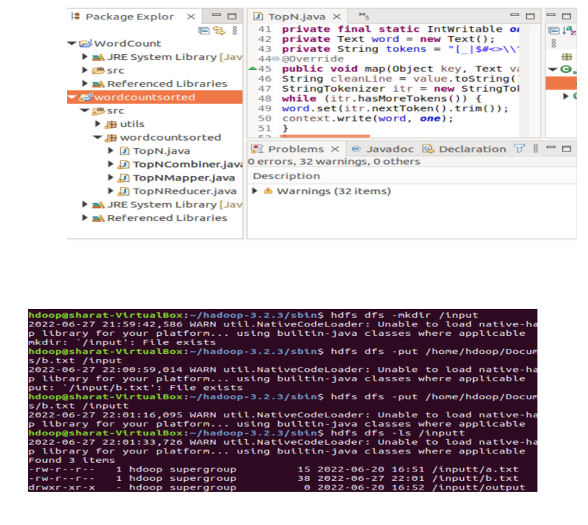

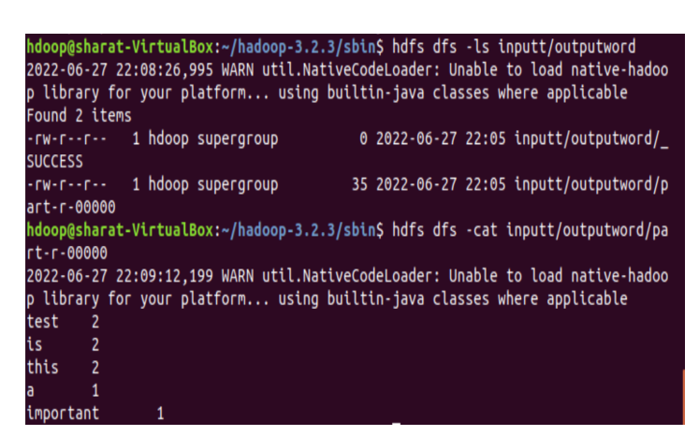

**8. Create a Map Reduce program to demonstrating join operation**

CODE:

// JoinDriver.java

import org.apache.hadoop.conf.Configured;

import org.apache.hadoop.fs.Path;

import org.apache.hadoop.io.Text;

import org.apache.hadoop.mapred.*;

import org.apache.hadoop.mapred.lib.MultipleInputs;

import org.apache.hadoop.util.*;

public class JoinDriver extends Configured implements Tool {

public static class KeyPartitioner implements Partitioner<TextPair, Text> {

@Override

public void configure(JobConf job) {}

@Override

public int getPartition(TextPair key, Text value, int numPartitions) {

return (key.getFirst().hashCode() & Integer.MAX_VALUE) %

numPartitions;

}}

@Override

public int run(String[] args) throws Exception {

if (args.length != 3) {

System.out.println("Usage: <Department Emp Strength input>

<Department Name input> <output>");

return -1;

}

JobConf conf = new JobConf(getConf(), getClass());

conf.setJobName("Join 'Department Emp Strength input' with 'Department Name

input'");

Path AInputPath = new Path(args[0]);

Path BInputPath = new Path(args[1]);

Path outputPath = new Path(args[2]);

MultipleInputs.addInputPath(conf, AInputPath, TextInputFormat.class,

Posts.class);

MultipleInputs.addInputPath(conf, BInputPath, TextInputFormat.class,

User.class);

FileOutputFormat.setOutputPath(conf, outputPath);

conf.setPartitionerClass(KeyPartitioner.class);

conf.setOutputValueGroupingComparator(TextPair.FirstComparator.class);

conf.setMapOutputKeyClass(TextPair.class);

conf.setReducerClass(JoinReducer.class);

conf.setOutputKeyClass(Text.class);

JobClient.runJob(conf);

return 0;

}

public static void main(String[] args) throws Exception {

int exitCode = ToolRunner.run(new JoinDriver(), args);

System.exit(exitCode);

}}

// JoinReducer.java

import java.io.IOException;

import java.util.Iterator;

import org.apache.hadoop.io.Text;

import org.apache.hadoop.mapred.*;

public class JoinReducer extends MapReduceBase implements Reducer<TextPair, Text, Text,

Text> {

@Override

public void reduce (TextPair key, Iterator<Text> values, OutputCollector<Text, Text>

output, Reporter reporter)

throws IOException

{

Text nodeId = new Text(values.next());

while (values.hasNext()) {

Text node = values.next();

Text outValue = new Text(nodeId.toString() + "\t\t" + node.toString());

output.collect(key.getFirst(), outValue);

}

}

}

// User.java

import java.io.IOException;

import java.util.Iterator;

import org.apache.hadoop.conf.Configuration;

import org.apache.hadoop.fs.FSDataInputStream;

import org.apache.hadoop.fs.FSDataOutputStream;

import org.apache.hadoop.fs.FileSystem;

import org.apache.hadoop.fs.Path;

import org.apache.hadoop.io.LongWritable;

import org.apache.hadoop.io.Text;

import org.apache.hadoop.mapred.*;

import org.apache.hadoop.io.IntWritable;

public class User extends MapReduceBase implements Mapper<LongWritable, Text, TextPair,

Text> {

@Override

public void map(LongWritable key, Text value, OutputCollector<TextPair, Text> output,

Reporter reporter)

throws IOException

{

String valueString = value.toString();

String[] SingleNodeData = valueString.split("\t");

output.collect(new TextPair(SingleNodeData[0], "1"), new

Text(SingleNodeData[1]));

}

}

//Posts.java

import java.io.IOException;

import org.apache.hadoop.io.*;

import org.apache.hadoop.mapred.*;

public class Posts extends MapReduceBase implements Mapper<LongWritable, Text, TextPair,

Text> {

@Override

public void map(LongWritable key, Text value, OutputCollector<TextPair, Text> output,

Reporter reporter)

throws IOException

{

String valueString = value.toString();

String[] SingleNodeData = valueString.split("\t");

output.collect(new TextPair(SingleNodeData[3], "0"), new

Text(SingleNodeData[9]));

}

}

// TextPair.java

import java.io.*;

import org.apache.hadoop.io.*;

public class TextPair implements WritableComparable<TextPair> {

private Text first;

private Text second;

public TextPair() {

set(new Text(), new Text());

}

public TextPair(String first, String second) {

set(new Text(first), new Text(second));

}

public TextPair(Text first, Text second) {

set(first, second);

}

public void set(Text first, Text second) {

this.first = first;

this.second = second;

}

public Text getFirst() {

return first;

}

public Text getSecond() {

return second;

}

@Override

public void write(DataOutput out) throws IOException {

first.write(out);

second.write(out);

}

@Override

public void readFields(DataInput in) throws IOException {

first.readFields(in);

second.readFields(in);

}

@Override

public int hashCode() {

return first.hashCode() * 163 + second.hashCode();

}

@Override

public boolean equals(Object o) {

if (o instanceof TextPair) {

TextPair tp = (TextPair) o;

return first.equals(tp.first) && second.equals(tp.second);

}

return false;

}

@Override

public String toString() {

return first + "\t" + second;

}

@Override

public int compareTo(TextPair tp) {

int cmp = first.compareTo(tp.first);

if (cmp != 0) {

return cmp;

}

return second.compareTo(tp.second);

}

// ^^ TextPair

// vv TextPairComparator

public static class Comparator extends WritableComparator {

private static final Text.Comparator TEXT_COMPARATOR = new Text.Comparator();

public Comparator() {

super(TextPair.class);

}

@Override

public int compare(byte[] b1, int s1, int l1,

byte[] b2, int s2, int l2) {

try {

int firstL1 = WritableUtils.decodeVIntSize(b1[s1]) + readVInt(b1, s1);

int firstL2 = WritableUtils.decodeVIntSize(b2[s2]) + readVInt(b2, s2);

int cmp = TEXT_COMPARATOR.compare(b1, s1, firstL1, b2, s2, firstL2);

if (cmp != 0) {

return cmp;

}

return TEXT_COMPARATOR.compare(b1, s1 + firstL1, l1 - firstL1,

b2, s2 + firstL2, l2 - firstL2);

} catch (IOException e) {

throw new IllegalArgumentException(e);

}

}

}

static {

WritableComparator.define(TextPair.class, new Comparator());

}

public static class FirstComparator extends WritableComparator {

private static final Text.Comparator TEXT_COMPARATOR = new Text.Comparator();

public FirstComparator() {

super(TextPair.class);

}

@Override

public int compare(byte[] b1, int s1, int l1,

byte[] b2, int s2, int l2) {

try {

int firstL1 = WritableUtils.decodeVIntSize(b1[s1]) + readVInt(b1, s1);

int firstL2 = WritableUtils.decodeVIntSize(b2[s2]) + readVInt(b2, s2);

return TEXT_COMPARATOR.compare(b1, s1, firstL1, b2, s2, firstL2);

} catch (IOException e) {

throw new IllegalArgumentException(e);

}

}

@Override

public int compare(WritableComparable a, WritableComparable b) {

if (a instanceof TextPair && b instanceof TextPair) {

return ((TextPair) a).first.compareTo(((TextPair) b).first);

}

return super.compare(a, b);

}

}  }

OUTPUT:

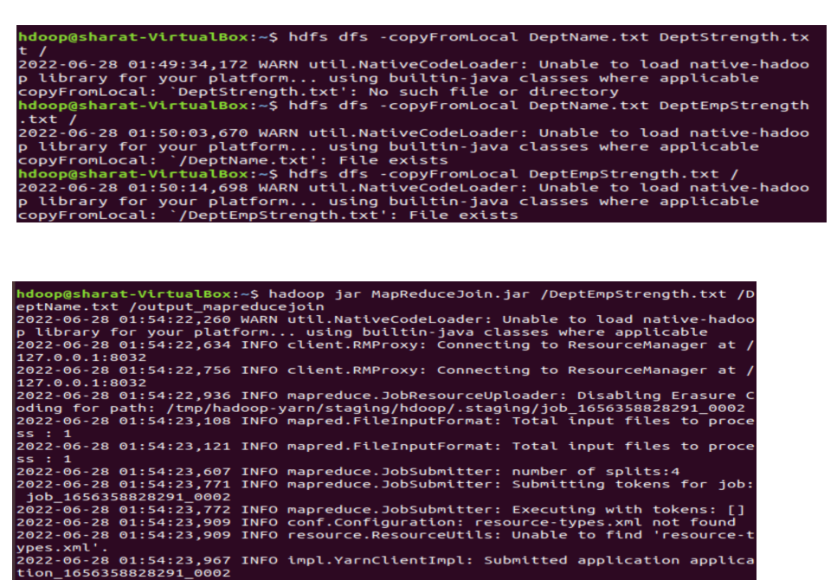

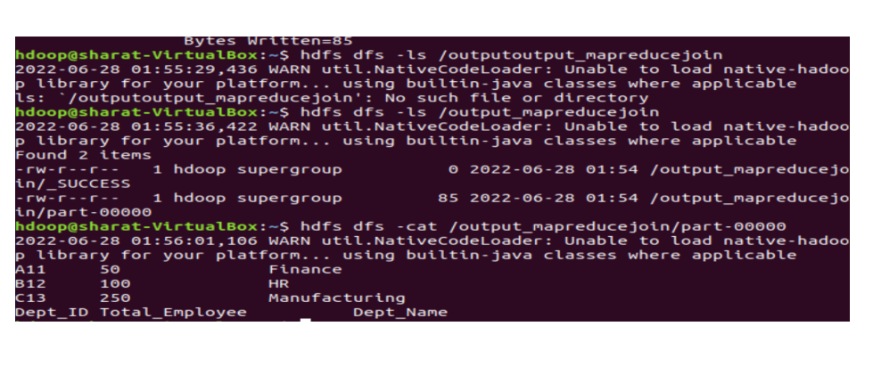

**9. Program to print word count on scala shell and print “Hello world” on scala IDE**

CODE:

**package** **wordcount**

**import** **org.apache.spark.SparkConf**

**import** **org.apache.spark.SparkContext**

**import** **org.apache.spark.rdd.RDD.rddToPairRDDFunctions**

**object** **WordCount** {

**def**

main(args**:** **Array**[**String**]) **=** {

//Start the Spark context

**val** conf **=** **new** **SparkConf**().setAppName("WordCount").setMaster("local")

**val** sc **=** **new** **SparkContext**(conf)

//Read some example file to a test RDD

**val** test **=**sc.textFile("input.txt")

test.flatMap {

line **=>** //for

each line

line.split(" ") //split

the line in word by word.

  } .map {

word **=>** //for

each word

(word, **1**) //Return a key/value tuple, with the word as key and 1 as value

.reduceByKey(**_** + **_**) //Sum

all of the value with same key

.saveAsTextFile("output.txt") //Save

to a text file

//Stop the Spark context

sc.stop

}

}

OUTPUT:

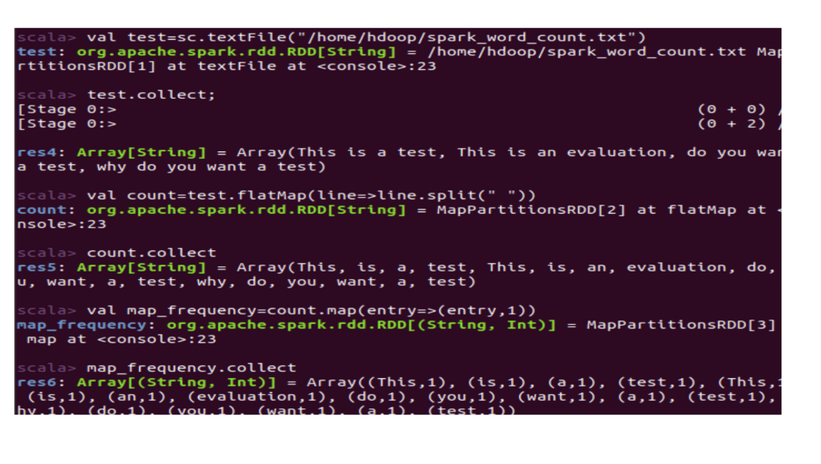

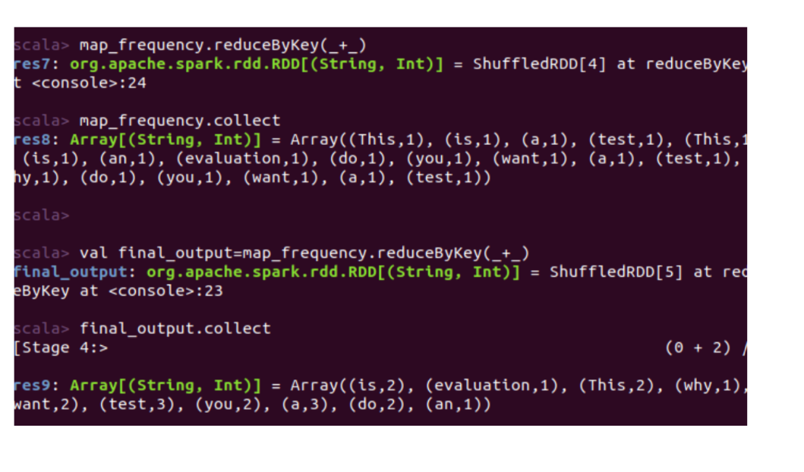

**10. Using RDD and FlatMap count how many times each word appears in a file and write out a list of words whose count is strictly greater than 4 using Spark**

CODE:

  val textFile = sc.textFile("/home/Desktop/test.txt")

val counts = textFile.flatMap(line => line.split(" ")).map(word => (word, 1)).reduceByKey(_ + _)

import scala.collection.immutable.ListMap

val sorted=ListMap(counts.collect.sortWith(_._2 > _._2):_*)// sort in descending order based on values

println(sorted)

for((k,v)<-sorted)

{

  if(v>4)

    {

     print(k+",")

       print(v)

       println()

     }

}

OUTPUT:

